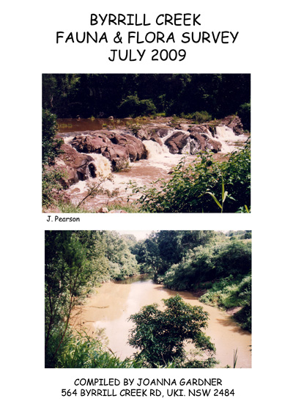

LIST OF CONTENTS

INTRODUCTION
Letter to Biolink, Ecological Consultants for the Repco Rally

APPENDIX 1 :
D. Parkins Byrrill Creek Fauna & Flora Survey 2000-2004
(Contributor to NPWS Atlas)

APPENDIX 2 :
Photos of Giant Barred Frog & Marble Frogmouth Owl, at Byrrill Creek.

APPENDIX 3 : WILDLIFE CARERS DATA BASES
i) Tweed Valley WildLife Carers’ Data Base 2006-2009 Byrrill Creek
ii) Tweed Valley WildLife Carers’ Data Base 2003-2006 Byrrill
Creek/Terragon/Mebbin
iii) Letter from President Tweed Valley WildLife Carers
iv) Friends of the Koala, Byrrill Creek Data 2007-2009

APPENDIX 4 :
i) Map: Tweed Shire Vegetation Management Strategy 2004 Koala Sitings
ii) Map: Byrrill/Mebbin area Tweed Shire Veg. Management Strategy 2004
Koala Sitings

APPENDIX 5 :
i) Byrrill Terragon Fauna Survey July 2009
ii) Threatened Species List

APPENDIX 6 : KOALA SIGHTING DOCUMENTATION
i) Malcom Bailey Letter
ii) Andrew McInerny Statement
iii) Prudence Morrison, Pretty Gully Diary Records 1995-2009
iv) Peter Symons Koalas on Road letter
v) Koala Rescue by Lea Brockhurst

APPENDIX 7 :
Byrrill Creek Wallaby population & Vehicle road kill letter Shirley Ross

APPENDIX 8 : BYRRILL CREEK VEGETATION & CONSERVATION STATUS
i) Byrrill Creek Vegetation & Koala Letter Rhonda James, ecologist
ii) R. James: Conservation of Iconic Species within priority areas in the
Tweed: Byrrill
iii) Byrill Creek Rehabilitation Plan Executive Summary
iv) Nth Rivers Catchment Management Authority Corridor Connection Plan
2009 Byrrill
v) R. Kooyman. Wollumbin State Forest Threatened Flora Species 2000

APPENDIX 9 : MAPS
i) National Parks & Wildlife Atlas: Byrrill Creek Koalas
ii) National Parks & Wildlife Atlas: Byrrill Creek Giant Barred Frog
iii) Biolink Vegetation Types & Threatened Flora & Bird Habitat
iv) Biolink Koala Habitat: Core & Potential
v) Byrrill Creek Area 2009: Sitings of Endangered, Vulnerable & other
Fauna
vi) Byrrill Creek Area 2009: (as above but zoomed in)
vii) Repco Rally Route

APPENDIX 10:
Letter to Repco Rally Australia dated 20th July, 2009

APPENDIX 11 : DVD FOOTAGE IN BYRRILL CREEK
i) Koala crossing Byrrill Creek Rd: 21/10/2006
ii) Koalas mating, Pretty Gully: 1/12/1999
iii) Platypus in Byrrill Lagoon: Spring 2002

I would like to thank the many people who have contributed to this survey:
In particular, Helen & Annette from Tweed Valley Wildlife Carers, Rhonda from Bushland Restoration Services, Denise for her survey, Janaki & Pete for their invaluable support, and the residents of Byrrill Creek for their contributions. (The survey is still to be fully collated!)

I try to walk softly on this beautiful land that I live on. We try to keep our carbon footprint to a minimum, and all this has been done powered purely by solar panels & a mini hydro electric plant.

I ask you, in all honesty: is this area, bounded by National Parks, home of endangered & vulnerable species, not to mention all the other animals, the place to run an international car rally for a private profit making company????

Joanna Gardner
INTRODUCTION
Steve Phillips
BioLink,
Ecological Consultancy firm for Repco Rally Australia

Joanna Gardner
564 Byrrill Creek Rd
Uki NSW 2484
Email peter.symons8@bigpond.com
Phone 02 66797039

16th July, 2009

Dear Steve,

I have been a resident and landholder at Byrrill Creek for 25 years. It is a bio diverse area with high conservation riparian status. It is a wildlife corridor linking Mt Warning National Park, Wollumbin National Park, Wollumbin State Conservation Area and Mebbin National Park.

Firstly, I am concerned that during your Ecological Assessment Survey of Byrrill Creek for Repco Rally Australia that there was no community consultation, imput or observations of fauna from long term residents who live in this valley, which would have provided valuable insight into your survey. I understand that Janaki Pearson contacted you by phone 2 months ago with information for your survey, but never had any confirmation that you included this within your assessment.

Secondly, the timing of your surveys in late summer and autumn could not be truly accurate nor indicative of early spring when the Repco Rally will be held. It is breeding season, and the fauna is far more active and mobile during spring. Nor does your assessment address the cumulative effect on wildlife of 5 Repco Rallies held over 10 years.

Thirdly, after reading through your report, I question the accuracy of some of your data and the conclusions that you made. Areas of particular concern include the endangered Giant Barred Frog, the endangered Spotted Quoll, vulnerable White-eared Monarch and Bush Hen, both very close to the road, and particularly Koala habitat areas.

Below are sightings from the Byrrill Creek area of Vulnerable & Endangered Species. 14 species so far are recorded.

1. Giant Barred Frog (Mixophyes iterates)
There have been 12 sightings of the endangered Giant Barred Frog within the Byrrill Creek area, 7 in close proximity to the road at the Hamlet, including I roadkill death (See photo Appendix 2 & Appendix 1, D. Parkins Survey & Appendix 5). Another sighting at the causeway of Cabbage Tree Creek (on the rally route), 5 at Pretty Gully, 2 of these near Byrrill Creek & in close proximity to Byrrill Creek Road. I understand that one of the reasons that Cadell Rd was removed from the rally route was the high incidence of the Giant Barred Frog there, & a documented study area there. Byrrill Creek shares the same water catchment area, so I would conclude, with the above sightings, that it is also a habitat for the Giant Barred Frog.

2. Spotted-tailed Quoll (Dasyurus maculates)
There have been 3 sightings in this area, two in the last 4 years on the Hamlet & at the back of a property on Kyogle Road, near the Byrrill Creek turnoff. During a sighting on Pretty Gully in 1995 the quoll was in the chicken pen & had killed a hen. (Appendix 5).

3. Bush Hen (Amaurornis olivaceus, Gallinula livacea)
Classified as vulnerable, 2 have been sighted on Byrrill Creek Road in 2 places: Pretty Gully Causeway 2008, and near the Hamlet, 2009 (Appendix 5).

4. The White- eared Monarch, (Monarcha leucotis)
Listed as vulnerable, was recorded 19 times from 2002-2004, in close proximity to the road and nesting close to the road (Appendix 1, D. Parkins Survey).

5.The Marbled Frog Mouth (Podargus ocellatus)
Classified as vulnerable, is relatively common to the Byrrill Creek area. During 2009 there have been almost daily sightings of resident Marbled Frog Mouths at Pretty Gully (Appendix 5). Also sighted at least 5 times between 2000 & 2001 and photographed (Appendix 1, D. Parkins Survey and photo).

6. Powerful Owl (Ninox Strenua), Barking Owl (Ninox Connivens) & Sooty Owl
Were recorded by D. Parkins on the Tweed Shire Council land, the latter quite close to the road (Appendix 1) also at Pretty Gully in May to June, 2009. The Sooty Owl was sighted for 1 week 21/4/01 at Pretty Gully (Appendix 5).

7. Wompoo Fruit Dove (Ptilinnopus magnificus)
Classified as vulnerable, these birds are heard continually during spring, summer & autumn in the rainforested areas within Pretty Gully. Sightings are rarer, 20 times per year by J. Gardner. Three other residents of Pretty Gully record often hearing them, two have sighted them. At Tallowood, closer to the creek there have been some sightings (Appendix 5).

8. Stephens Banded Snake
Seven sightings in total. In December 2005 a pair mating in the ceiling in a house at Pretty Gully fell from the roof & the local snake man was called in. Three other sightings at Pretty Gully also D. Parkins (Appendix 5 & 1).

9. Glossy Black Cockatoo (Calyptorhynchus lathami)
Seen fairly often by 2 residents on the Hamlet whose homes are in close proximity to Casuarina Forests, also at Pretty Gully and Tallowood but rare sightings (Appendix 5).

10. Red legged Pademelon (Thylogale stigmatica)
The Tweed Valley Wildlife Records report a female Red Legged Pademelon (vulnerable) in the Brays Creek area in May 2006 (Appendix 3, TVWC Survey).

11. The Stuttering Frog (Mixophyes balbus)
Has been observed at Pretty Gully and its call recorded, although not in close proximity to the road (Appendix 5).

12. Koala (Phascolarctos cinereus) Habitat Areas
I note on your maps the areas near the Wollumbin State Conservation Area that are core Koala habitat areas & potential habitat. However there are many more areas along Byrrill Creek that are core habitats and corridors for Koalas. The area of Pretty Gully running down the ridgeline north of Byrrill Creek is a core habitat area (Appendix 4 Tweed Shire Ecograph Vegetation Koala Sitings). It has mixed forest of Tallowoods (Koala primary food source) and Grey Gums, Flooded Gums, Iron Barks, Blackbutts and Forest Oaks (Koala secondary food source). Residents hear Koalas frequently. P. Morrison has detailed Diary Sightings since 1995 (See Appendix 6(iii) & Appendix 5 also Appendix 11 film footage Koalas crossing road).

The land “Tallowood” of A. & R. McInerny on the southern side of Byrrill Creek, is a core Koala habitat area. They have 2 resident male Koalas close to their house. Their next door neighbours also have resident Koalas (See Appendix 6(ii) Statement). Adjoining McInerny’s land along Terragon ridge are the “Ranch” and “The Hamlet”. Land holders in these areas consistently hear Koalas in spring & summer and sightings are common in spring. 22 multiple sightings have been recorded. 5 dead Koalas found, 3 killed by dogs, 2 by disease, drought or fire. (Appendix 5 also all Maps Appendix 9).

Koalas on the Road;
We have 6 sightings of Koalas: males, juveniles and breeding females on the road, 5 in close vicinity of Pretty Gully Causeway. GPS Lat 28º 26.53 Long 153º 14.54 Datum WGS84 (Appendix 6(i) Letter M. Bailey and Appendix 6(iv) Letter P. Symons) GPS Lat 28º 26.48 Long 153º 14.54 Datum WGS84 (Appendix 11 Video of October 2006).

It is obvious from this amount of sightings that this area is a Koala corridor linking the land on the south and north sides of Byrrill Creek, using a narrow land bridge near the lagoon. Rhonda James, ecologist, supports this theory (See Appendix 8(i).)

Note that this area is not even delegated as potential habitat in your survey.

As well as the above there are another 5 recorded sightings, including females with young, near the Hamlet (See Appendix 1, D. Parkins Survey). There have been 5 Koala rescues by the Tweed Valley Wildlife Carers, one of which was on the road over the last few years (Appendix 3(iii) Friends of the Koala Data Base Records).

With all of this data, you may need to adjust your delineated areas of Koala habitat for Repco Rally and ensure they carry out your advised Koala Management Strategies.

Other Fauna
Above and beyond your report, which only addressed endangered and vulnerable Species, I would like to record that the Byrrill Creek area is home to a vast and varied population of fauna (Appendix 5), the most prolific being the Red Necked and Swamp Wallabies, a horrific eight of which have been killed this last year in motor vehicle accidents, 2 had joeys, I of which survived. (Appendix 3 (i)TVWC Data Base Records & Appendix 7 letter from land holder). The majority of these vehicles were traveling 40-50 kmph. The Rally cars will be travelling up to 3 to 4 times this speed. Above and beyond vehicle kill, is the silent killer of stress myopathy on the macropod family. The noise & action of both the Rally & your recommended preventative measures before the race, will contribute to far more deaths of this nature, than road kill. Stress myopathy will cause death, affect breeding cycles, and go unrecorded as an overall effect of the Rally.

Riverine and Platypus Habitat:
Along the length of Byrrill Creek Road, the road is in close proximity to the creek in many areas. There are 11 river and creek crossings: 6 that are on the Rally route, one of these at Cabbage Tree Creek with a permanent flow of water over it. Nearby was one of the sightings of the endangered Giant Barred Frog. Platypus are found along the whole length of Byrrill Creek in the deep waterholes. One lagoon, near Pretty Creek Causeway, Platypus are sighted regularly, especially in spring. This particular Platypus habitat is on a narrow slippery corner and could easily be a potential car crash site, polluting the water quality. We have Platypus film of this area: (Appendix 11 DVD Footage & Appendix 9(v) Map).

High Conservation Riparian Area:
I have focused primarily on fauna in my survey, as time is of the essence, fauna is much more easily identified by local residents, and I feel that the most impact of the Repco Rally will be on the wildlife that lives in our valley.

However I note that in ecological consultant, Rob Kooyman’s Survey in 2000 of Wollumbin State Forest, now National Park & Conservation Area, and bordering on to this area, that 3 species were Schedule 1, 6 species were Schedule 2, and another 17 species classified in the ROTAP of varying classifications. (Appendix 8 (v).)

As a general overview of the area, the Tweed Catchment Stressed Rivers Assessment Report 1999 identified the Byrrill Creek subcatchment area as the highest conservation value riparian area within the Tweed because of its high proportion of riparian vegetation cover and high percentage of diversity of wet flora species and Schedule 1 & 2 wet fauna species (Appendix 8(i), (ii) & (iii).)

Byrrill Creek has been part of a Northern Rivers Catchment Management Authority Riparian Rehabilitation Scheme for the last 2 years which was funded by the Australian and NSW Government through the Natural Heritage Trust (Appendix 8(ii) and (iii).)

In 2009/10 Byrrill Creek will be part of the Northern Rivers Catchment Management Authority project, to enhance landscape connectivity, through strategic habitat corridors, using revegetation & rehabilitation of existing native vegetation. The majority of landholders with riparian zones along Byrrill Creek will be participating. (See Appendix 8 (iv).)

In conclusion I would ask that you reassess the Byrrill Creek Route, utilising the information I have provided above, and if possible recommend to the Repco Rally Organisers, that the Byrrill Creek area be taken off the route of the Rally.

At the very least, to recommend to Repco Rally Organisers, that there be adequate safeguards on all creek crossings, vehicle crash safety barriers at the Platypus lagoon habitat area, warning signs, including wallaby habitat, and that core Koala habitat measures be implemented along the sections I have shown to be a corridor and habitat areas.

I would appreciate a reply as soon as possible,

Yours sincerely,
Joanna Gardner
APPENDIX 1: D. Parkins, Byrrill Creek Survey 2000-2004

1/07/2009
Re: Byrrill Ck Flora and Fauna Surveys

To whom it may Concern,

I am writing in response to a request for more information concerning records of rare and endangered flora and fauna in Byrrill Ck. As one who is qualified in Natural Resource Management, I have been a voluntary contributer to the NSW Atlas of Wildlife Database since December 2000 and have also conducted a number of surveys in and around Byrrill Creek including riparian and water quality assessments.

To date, I have submitted well over 640 Fauna records to the database as well as a number of submissions concerning plant species. These include a number of rare and endangered species which may be impacted upon due to their close proximity to the road and creek. Increased traffic, oil leaks and exhaust pollution are of concern in this regard as is the disturbance or removal of creek/roadside riparian vegetation. I also have concerns with the accuracy of some independent ecological assessments which assign a low or medium threat in regard to some of the endangered species.

Some points in question:

- Mixophyes iteratus (Giant Barred Frog)
- Monarcha leucotis (White-eared Monarch)
- Hollow bearing Trees

Mixophyes iteratus
Some reports based on Atlas of wildlife data assume this endangered species was recorded in and directly beside the water but this is not the case. As the person who submitted these reports to the database, the frogs in question were observed on the road near to the creek a number of times between 2002 – 2006. This includes both adult and immature specimens and in one instance, a recorded death due to roadkill in Feb 2004.

Monarcha leucotis
Has been recorded over 19 times in trees right beside Byrrill Ck Rd. This includes both individuals, breeding pairs and nest sites. Breeding cycles are from about Sept – Feb and there are some concerns in relation to the effects of roadside exhaust pollution and noise levels on breeding pairs and their ability to successfully rear hatchlings. Another concern is damage to their habitat and nesting sites through roadside accidents and human activities along the side of the road.

Hollow Bearing Trees
A recent assessment made for Repco Rally Australia http://rallyaustralia.com/wp-content/uploads/1853%201%20Final_RRA_Tweed_Report%20final%202.pdf (pg 21) has indicated that only one hollow bearing tree was recorded during their survey within proximity to Byrrill Ck Rd. This data is not indicative of a thorough or comprehensive assessment and may be misconstrued as being accurate. There are in fact a number of hollow bearing trees along a 7-10km stretch of road and a number of endangered owls have already been recorded within their vicinity including the Barking Owl, Marbled Frogmouth and the Powerful Owl.

It is my belief that some of these concerns have not been adequately assessed or addressed in relation to other data covering a period of a number of years, therefore I’d like to submit a list of rare and endangered species I have recorded for the Atlas of Wildlife database for your consideration.

Yours sincerely
D. Parkin (Dip. Nat Res Mgt . Acc. Chem Apps)
Email: dhanishta7@gmail.com

Common Name | Dates | Habitat Type | # of Individuals | Notes
Giant Barred Frog | Jan 03  Oct 03  Feb 04 | RD  GR  EW + RD | 1 Adult  1 Immature Adult  3 Adults – 1 roadkill | Photographed  Roadkill occurred  on Byrrill Ck Rd
White-Eared Monarch | Nov 02  Aug 03  Sept 03  Oct 03  Nov 03  Dec 03  Jan 04  Mar 04  Apr 04 | IT  IT  IT + EW +RD  IT + EW  IT  IT  IT  IT  IT | 1 Male Adult  1 Adult  2 Adults 1M/1FM  2 Adults  1 Adult  1  1  1  1 | Breeding/Nesting  Recorded 10 times  during Sept.  Nesting beside Rd
Marbled Frogmouth | Dec 00  Feb 01  Apr 01  Jun 01  Aug 01 | IT  EW  IT  IT  IT | 1 Male  1  1  1  1 | Photographed
Bush Hen | Jan 04  Feb 04 | GR + UG  EW + UG | 1  7 – 2 Adults/5 Chicks
Stephens Banded Snake | Feb 04 | GR | 1
Powerful Owl | May 01 | FL | 1
Glossy black Cockatoo | Feb 04 | IT | 2 | Feeding in casuarina  trees
RichmondBirdwing  Butterfly | Sep 03  Nov 03 | LS  BU | 1  1
Koala * | Between  Mar 01 – Nov 03 | IT + MC + GR UC | 5+ | Not less than 5  Individuals were  Recorded during  this time including mothers with  infants.
Barking Owl | Jul 08 | IT + AC

Notes: IT – In trees, GR – Ground, MC – Mid canopy, FL – Flying within canopy, UG – Undergrowth, LS – Low shrubs, BU – In Building, EW – Edge of Water, RD – On Road * Dates too numerous to list here.

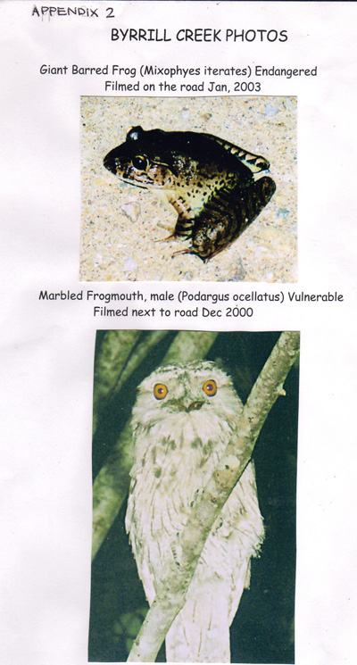
APPENDIX 3 (i)

 |  | TWEED VALLEY WILDLIFE CARERS DATABASE 2006-2009
CallDate |  | AnimalSpecies | LifePhase | Sex | LocationFound | InjuryDesc | CauseDesc
 | 13/12/06 | Kookaburra | B | U | Brays Creek | Nothing apparent | Fallen
 | 6/1/07 | Black-faced Cuckoo-shrike | B | U | Brays Creek | Nothing apparent | Fallen
 | 18/6/07 | Butcherbird | A | U | Brays Creek | Nothing apparent | Unknown
 | 18/3/08 | Green Tree Snake |  |  | Brays Creek
 | 8/10/08 | Magpie | J | U | Brays Creek | Undernourished/  dehydrated | Fallen
 | 8/10/08 | Magpie | J | U | Brays Creek | Undernourished/  dehydrated | Fallen
 | 29/10/08 | Butcherbird | B | U | Brays Creek | Nothing apparent | Fallen
 | 22/3/07 | Swamp Wallaby | U | U | Byrill Creek | Body injury | Motor Vehicle
 | 23/3/07 | Koala | A | M | Byrill Creek | Eye injury | Disease
 | 25/5/07 | Crimson Rosella | A | U | Byrill Creek | Tail injury | Unknown
 | 26/5/07 | Crimson Rosella | U | U | Byrill Creek | Concussed/stunned | Motor Vehicle
 | 18/7/07 | Black Flying-fox | U | U | Byrill Creek | Unknown | Unknown
 | 18/7/07 | Black Flying Fox | U | U | Byrrell Creek | Unknown | Unknown
 | 29/4/08 | Goulds Long-eared Bat | A | M | Byrrell Creek | Wing Injury | Unknown
 | 5/5/08 | Marbled Frogmouth | A | U | Byrrell Creek | Wing injury | Unknown
 | 13/5/08 | Figbird | U | U | Byrrell Creek | Unknown | Cat Attack
 | 15/7/06 | Tawny Frogmouth | A | U | Byrrill Creek | Eye injury | Motor Vehicle
 | 13/10/06 | Red-necked Wallaby | B | M | Byrrill Creek | Nothing apparent | Motor Vehicle
 | 10/7/08 | Red-necked Wallaby | A | F | Byrrill Creek | Forelimb injury | Entanglement
 | 10/7/08 | Red-necked Wallaby | B | F | Byrrill Creek | Nothing apparent | Entanglement
 | 10/7/08 | Red-necked Wallaby | J | U | Byrrill Creek | Nothing apparent | Entanglement
 | 12/8/08 | Northern Brown Bandicoot | A | U | Byrrill Creek | Nothing apparent | Trapped
 | 29/8/08 | Koala | A | U | Byrrill Creek | Nothing apparent | Unknown
 | 11/9/08 | Koala | U | U | Byrrill Creek | Eye injury | Disease
 | 9/11/08 | Tawny Frogmouth | J | U | Byrrill Creek | Nothing apparent | Fledging/  learning to fly
 | 10/11/08 | Brush Turkey | B | U | Byrrill Creek | Nothing apparent | Natural causes  Congenital
 | 3/2/09 | Crested Pigeon | U | U | Byrrill Creek | Leg - birds | Motor vehicle
 | 7/2/09 | White-throated Nightjar | A | U | Byrrill Creek | Wing injury | Motor vehicle
 | 22/2/09 | Wallaby | A | U | Byrrill Creek | Body injury | Motor vehicle
 | 28/2/09 | White-throated Needletail  Swif | A | U | Byrrill Creek | Wing injury | Motor vehicle
 | 2/3/09 | Swamp Wallaby | U | U | Byrill Creek | Body injury | Motor Vehicle
 | 12/4/09 | Swamp Wallaby | B | F | Byrrill Creek | Nothing apparent | Motor vehicle
 | 5/5/09 | Bandicoot | U | U | Byrrill Creek | Hindlimb injury | Unknown
 | 24/8/06 | Carpet Python | A | U | Teragon | Neck injury | Motor Vehicle
 | 1/12/06 | Oriole | B | U | Terragon | Nothing apparent | Fallen
 | 16/1/08 | Carpet Python | A | U | Terragon | Nothing apparent | Unsuitable Environment
 | 14/1/09 | Flying-fox | U | U | Terragon | Hindlimb injury | Unknown
 | 23/2/09 | Pheasant Coucal | B | U | Terragon | Nothing apparent | Dog attack
 |  |  | B=Baby
 |  |  | J=Juvenile
 |  |  | A=Adult
 |  |  | U=Unknown

APPENDIX 3 (ii)

 | TWEED VALLEY WILDLIFE CARERS DATABASE 2003 -2006
CallDate | AnimalSpecies | AnimalLifePhase | AnimalSex | LocationFound
30-Apr-06 | Australian Grebe | Juvenile | U | Brays Creek
17-Sep-05 | Black Flying-fox | Adult | M | Brays Creek
07-Nov-04 | Cattle Egret | Unknown | U | Brays Creek
18-Jul-03 | Echidna | Juvenile | U | Brays Creek
21-Feb-03 | Kookaburra | Juvenile | U | Brays Creek
30-Dec-05 | Magpie Lark | Baby | U | Brays Creek
30-Dec-05 | Magpie Lark | Baby | U | Brays Creek
21-Jan-05 | Purple Swamp Hen | Juvenile | U | Brays Creek
30-May-06 | Red-legged Pademelon | Adult | F | Brays Creek
14-Mar-04 | Brown Tree Snake | Adult | U | Byrrill Creek
28-Dec-05 | Brown Tree Snake | Unknown | U | Byrrill Creek
08-Dec-04 | Carpet Python | Adult | U | Byrrill Creek
25-Nov-05 | Eastern Brown Snake | Adult | U | Byrrill Creek
28-May-05 | Finch | Unknown | U | Byrrill Creek
24-Aug-05 | Koala | Adult | M | Byrrill Creek
27-Aug-05 | Koala | Juvenile | M | Byrrill Creek
08-Feb-04 | Marbled Frogmouth | Adult | U | Byrrill Creek
11-Apr-04 | Mountain Brushtail Possum | Juvenile | F | Byrrill Creek
02-Nov-04 | Mountain Brushtail Possum | Baby | F | Byrrill Creek
04-Nov-03 | Red-necked Pademelon | Adult | U | Byrrill Creek
23-Oct-03 | Sugar Glider | Baby | F | Byrrill Creek
12-Sep-05 | Swamp Wallaby | Baby | F | Byrrill Creek
10-Apr-06 | Swamp Wallaby | Adult | F | Byrrill Creek
10-Apr-06 | Swamp Wallaby | Baby | U | Byrrill Creek
15-Jun-06 | Tawny Frogmouth | Adult | U | Byrrill Creek
17-Jul-04 | Koala | Adult | M | Mebbin
22-Jun-04 | Mountain Brushtail Possum | Baby | U | Mebbin
02-Jun-05 | Red-necked Pademelon | Baby | U | Mebbin
02-Jun-05 | Red-necked Pademelon | Adult | F | Mebbin
28-Sep-05 | Carpet Python | Adult | M | Teragon
28-Sep-05 | Carpet Python | Adult | F | Teragon
28-Sep-05 | Carpet Python | Adult | M | Teragon
24-Jun-06 | Carpet Python | Adult | U | Teragon
06-Mar-06 | Koala | Adult | M | Teragon
25-May-05 | Kookaburra | Adult | U | Teragon
06-Jan-06 | Olive-backed Oriole | Baby | U | Teragon
29-Nov-03 | Swamp Wallaby | Adult | U | Teragon

APPENDIX 3 (iii) Letter from President Tweed Valley Wildlife Carers

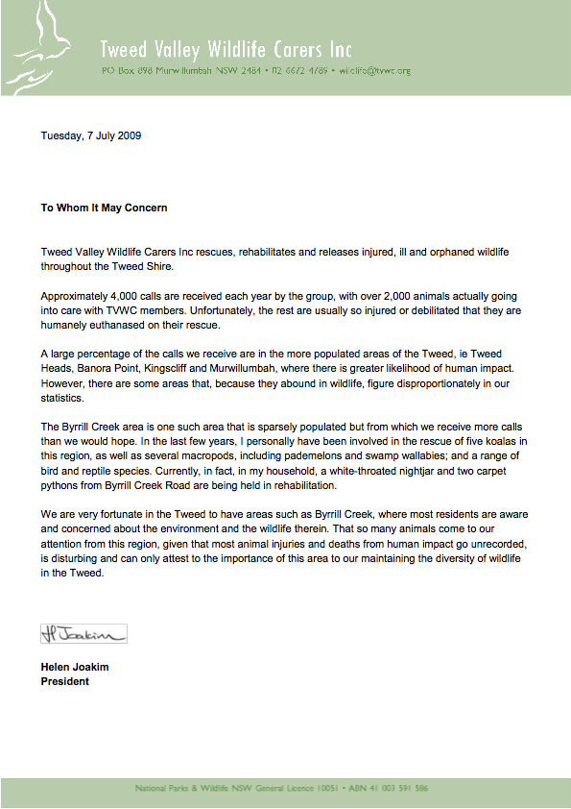

APPENDIX 3 (iv) Friends of the Koala, Byrrill Creek Data 2007-2009

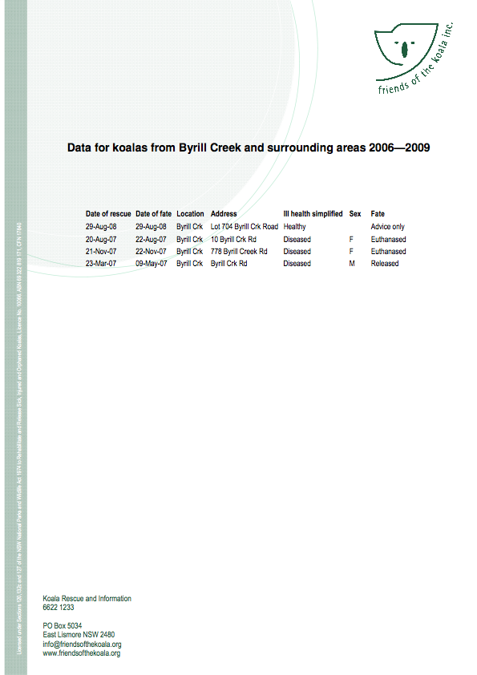

APPENDIX 4 (i) Map: Tweed Shire Vegetation Management Strategy 2004
Koala Sightings
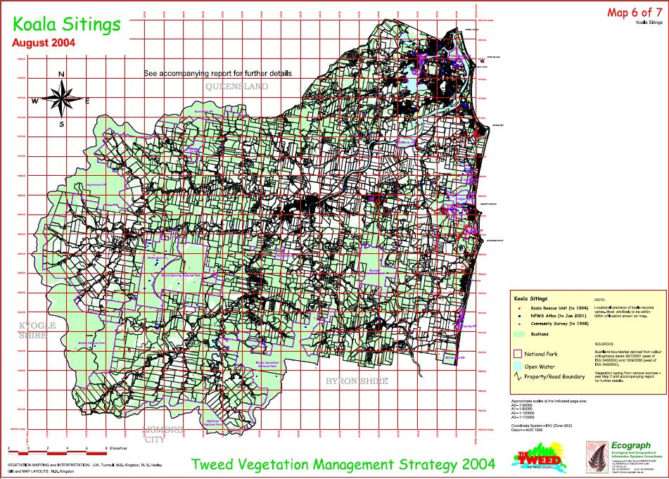

APPENDIX 4 (ii) Map: Byrrill/Mebbin area Tweed Shire Vegetation Management Strategy 2004 Koala Sitings
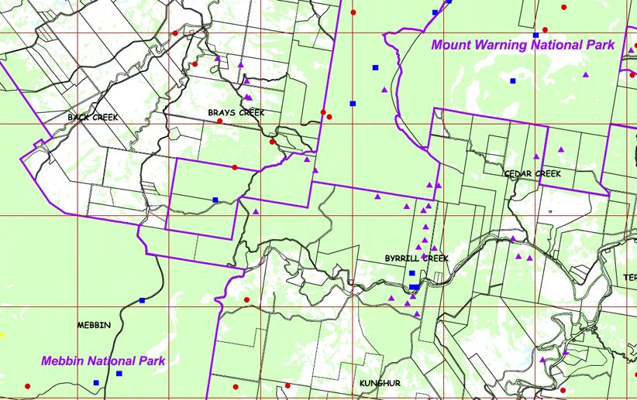
APPENDIX 5 (i) Byrrill & Terragon Fauna Survey, July 2009

25 Surveys were handed out & 18 have been returned so far. I have read through all of them, collated all Threatened & Vulnerable Species (EPBC & State Acts). Collating all the data is a time consuming task and still ongoing. See Master for statistics collated so far.

FAUNA SURVEYED INCLUDES ALL OF THE BELOW

OTHER  Land Mullet  Eastern Water Dragon  Frill neck Lizard  Eastern Long necked Turtle  Green Tree Frog  Red eyed Green Tree Frog  Great Barred Frog  Cane toad | MAMMALS & MONOTREMES  Bandicoot  Dingo  Echidna  Black Mt Brush tail Possum  Common Brush tail Possum  Ring tail Possum  Sugar Glider  Pygmy Possum  Red Necked Pademelon  Red Necked Wallaby  Swamp Wallaby  Eastern Grey Kangaroo  Little Red Flying Fox  Microbat  Platypus | BIRDS  Alberts Lyrebird (T)  Australian Figbird  Australian Owlet-Nightjar  Blue Winged Kookaburra  Brown Cuckoo Dove  Brush Turkey  Bush Hen (T)  Butcherbird  Crimson Rosella  Dollarbird  Emerald Dove  Finch  Glossy Black Cockatoo (T)  King Parrot  Laughing Kookaburra  Magpie  Musk Lorikeet  Nightjar  Noisy Friarbird  Noisy Myna  Pacific Baza  Pied Butcherbird  Pied Currawong  Powerful Owl (T)  Rainbow Lorikeet  Red-browned Firetail  Red-rumped Parrot  Satin Bowerbird  Sooty Owl (T)  Spangled Drongo  Square-tailed Kite (T)  Striped Honeyeater
OTHER  Land Mullet  Eastern Water Dragon  Frill neck Lizard  Eastern Long necked Turtle  Green Tree Frog  Red eyed Green Tree Frog  Great Barred Frog  Cane toad | SNAKES  Eastern Brown Snake  Eastern Small eyed Snake  Brown Tree Snake  Green Tree Snake  Death Adder  Rough Scale Snake  Red Bellied Black  Blue Bellied Black  Carpet Python  Bandy Bandy Snake  Yellow face Whip Snake  Golden Crown Snake

APPENDIX 5 (ii)
THREATENED SPECIES LIST

SPECIES | Sighted:  Number  Indications:  Road Number  G= Ground  T=Tree  RD=road  W=water  A= Air  PG=Pretty  Gully | Evidence  Eg: sounds, tree scratches droppings, burrowing, hunting etc | HOW OFTEN eg  Specific Date or  Once=x1  Twice=x2  What season?  Resident=R  Monthly=M  Yearly=YR | Within last 5 years | Before 2004 | Alive | Injured | Road kill  where | Killed by other means
Spotted Tail Quoll | 3 x G  1PG &1m  1KyogleRd |  | V rare x 1 for all | 2
Black-headed Flying Fox (T) | 9 T & A |  | Season=6  Daily=3 | 9 | 7 | Small flocks |  | 1
Koala (V) | 22+  6 RD (5 at PG PG Ck)  14 T | All surveys had heard them thru year | Resident at 3 homes 2, 1xYr  15 Spring Summer | 12 | 12 | 14 | 7 | 2  Kyogle rd | 5  3=Dogs  2=Disease
Giant Barred Frog(T) | 12: 7 GR1W at Hamlet  5 PGul: 2GR,  2 PG Ck, 1G  1 GR Cabb Tree Ck |  | Rarely Summer/  spring | 9 | 2 | 11 |  | 1 Hamlet
Marbled Frogmouth | 15 + 5 x T  D.Park | 4x heard | 2x Res PG Daily | Yes |  | Yes
Barking Owl | 2: I x T,  D. Park 1xT  PG | 2 heard | March 2009  26/6/2007 | 2 |  | Yes
Powerful Owl | 2: I x T  D. Park 1xT  PG | 2 heard | 3/8/03 & March 2009 | 2 | 1 | Yes
Sooty Owl | 5: 5x TR  PG | 23/6/07 heard | 23/4/09, 17/11/03, 3/3/02, 8/9/02  21/4/01 1 week,nest | 2 |  | Yes
Stephens Banded  Snake (not Bandy Bandy) | 7: 3xT PG,  2xG Ham  1 DP, 2 x  house roof  PG PG |  | 1994 PG 2/3/99 PG  27/3/03 PG 2/04 Ham  2mating rf Dec 2005 | 3 | 4 | Yes
Loveridges Frog | 1 PG near house  photo |  | 26/2/09 |  |  | Yes
Glossy Black Cockatoo | 2 group Ham | 4 | 1x res group Seas  1xRare | 2 |  | Yes
White eared Monarch | 10 Hamlet D.Park Nest near rd |  | Nov 02-Apr 04 |  |  | Yes
Wompoo Fruit Dove | 20+Common  on PG | 8 heard | 4x PG 6/5/04  20+ Sp,Sum,Aut | 24 | 24 | Yes
Bush Hen | 4: groups2-4  3xPG  1xHam |  | 2006-2009 | 4 |  | Yes

APPENDIX 6 (i) Malcolm Bailey Letter

M J Bailey
Kalang
506 Byrrill Creek Road
Uki NSW 2484

3rd July 2009

I have lived at 506 Byrrill Creek road since 1994 and my property is situated where the fresh spring waters of Pretty Creek and Byrrill Creek join and is located approximately 100 metres from the creek area known as the lagoon and the causeway on Byrrill Creek road across the small creek known as Pretty Creek.

Every year since moving here we have heard the Koala mating call or as I call it the mating grunt in the spring time through to late summer, which I understand is the call of male koalas stating their territory and calling for a mate, immediately across the creek from my house and surrounding the lagoon area and the adjoining properties, in particular around the pretty creek causeway located on Byrrill Creek road as this is where the creek is at its narrowest point.

This area provides a natural wildlife corridor for the animals to cross the creek from the southern north facing hills to the northern side of the creek so they can access the vast and many Koala food trees situated near here and gain access to the community protected land and onto the National Park surrounding us.

It is clear that this is a wildlife corridor.

In fact, whilst on several morning walks to visit the platypus in the lagoon, just last year during the late winter to early spring season, I have seen up close at least two Koalas and one carrying the baby Joey on its back in this corridor.
GPS Lat 28º 26.53 Long 153º 14.54 Datum WGS84

This female koala was near the road and I assisted the koala it by encouraging this mother carrying its Joey to get off the road as soon as possible to avoid any conflict with the present sparse traffic flow.

During my 15 years here, I only visit the lagoon perhaps once a month to witness the platypus and have seen these koalas using this corridor along the creek known as Pretty Creek during the past two years.

Signed

-------------------------------------
M J Bailey.

APPENDIX 6 (ii) Koala Research, Andrew McInerny

BYRRILL CREEK FAUNA SURVEY JULY 2009

Statement from Andrew McInerny of “Tallowood” 665 Byrrill Creek Rd 11th July

Our land is on the southern side of Byrrill Creek & I consider it a main koala habitat. Tree species are predominantly Grey Gum and Iron bark with Blackbutt, Flooded Gum, and Tallowood to a lesser extent. Closer to the creek are Sydney Blue Gums. We have 2 resident male koalas, sometimes seen in the Ironbark near our garage. We hear Koalas constantly, in fact just last night, however sightings are rarer. During mating time we hear the females as well. We found a dead immature koala on the ground further up the ridge 18 months ago. Prior to 2004, we sighted a female on the ground. We have also seen trees, within the last 5 years, with scratch markings on them.

Andrew McInerny & Robyn McInerny Hoopmann

APPENDIX 6 (iii) Prudence Morrison, Pretty Gully Diary Records 1995-2009

KOALA SIGHTINGS DIARY RECORDS 1995-2009
Prudence Morrison, Lot 11, 564 Byrrill Creek Road, Uki NSW 2484

1995
28/1/95 Koalas seen in trees west side of house
9/2/95 Male Koala calling
15/2/95 Koala sighted on ground moving tree
11/3/95 Same Koala still here (remained near house for another week)
13/6/95 Male Koala (calling)
1996
27/9/96 Koala seen in tree
3/10/96 Koala seen in tree
17/10/96 Male and Female Koala seen in trees near the house
28/10/96 Koalas seen in trees
1997
22/1/97 Koala seen in tree
28/8/97 Female Koala and baby seen in tree west of house
30/9/97 Lots of Koalas seen and heard in trees near the house
13/11/97 Male Koala (calling)
6/12/07 Koala seen in tree
1998
3/1/98 Male Koala (calling)
14/9/98 Koala seen in tree
27/9/98 Koala seen near house in tree
12/10/98 Koalas heard calling
17/10/98 Koalas heard calling near house
1999
18/6/99 Koalas seen and heard all week near the house
7/8/99 Koala calling male
4/9/99 Koala seen in tree
7/9/99 Koala seen in tree
18/11/99- Koalas seen and heard Male and Female till
27/11/99
29/11/99 Saw Koalas mating in gum in orchard
1/12/99 Saw Koalas mating in trees behind the house
2000 I Cannot find my diary for 2000
2001
21/2/2001 Dead female Koala found under tree behind the house (Sth) in area
where they have been sighted mating in past years.
22/3/01 Male Koala call.
3/4/01 Koala seen in tree
5/5/01 Very large Koala in tree west of house
14/6/01 Koala seen in tree
19/7/01 Koala seen in tree
7/9/01 Koala seen in tree
19/9/01 Koala seen in tree
29/9/01 Koala seen in tree
11/10/01 Two Koalas seen in the same tree
14/10/01 Koala seen in tree
21/10/01 Koala seen in tree
3/11/01 Koala seen in tree
6/11/01 Koala seen in tree
10/11/01 Koala seen in tree
18/11/01 Male and Female Koalas seen and heard in trees west of house
2002
30/5/02 Female Koala heard calling
20/7/02 Koala seen in tree
17/8/02 Koala seen in tree
21/8/02 Koala seen in tree
9/9/02 Koala seen in tree
18/9/02 Koala seen in tree
24/9/02 Koala seen in tree
29/9/02 Koala seen in tree
4/10/02 Koala seen in tree
15/11/02 Three Koalas seen in the trees north of the house
9/12/02 Koala seen drinking rain water dripping from the bark of tree west
of house during rain. Pretty Creek had stopped running on the
7/12/02 so very dry here.
2003
2/1/03 Koala seen in tree
5/1/03 Koala seen in tree
13/103 Koala seen in tree
3/2/03 Koala seen in tree
2/4/03 Koala seen in tree
15/7/03 Male and female Koala seen and heard calling for three days here
1/8/03 Male Koala calling
4/8/03 Two Koalas seen in trees
14/8/03 Koala seen in tree
30/8/03 Koala seen in tree
10/9/03 Koala seen in tree
18/11/03 Koala seen in tree
2004 No detailed notes taken but koalas heard sporadically through
out the year.
- Dingo sightings recorded through out the year, koalas heard
sporadically, & few Koala sightings
4/4/05 Dingo seen near house
3/5/05 Dingo seen near house
18/6/05 Dingo seen near house
27/9/05 Dingo near house.
28/ 9 05 Koala in tree west of house
26/11/05 Dingo seen near house
17/12/05 2 Dingoes seen at house
Dingo pack in the area baited after contacting National Parks
Services for help, as a dead koala found 100 meters from our house
had bite wounds.etc.
2006 Dingoes still in the area and few Koala sightings.
13/1/06 Dingo in garden (note all sightings 2005-2006 are near to the full moon)
1/2/2006 Koala seen near house
12/4/06 Dingoes seen near the house
25/10/06 Koala grunting 10.30pm
2007
6/9/07 Dead Koala found on our driveway badly infected ear
27/9/07 Koalas seen and heard near house
2008
18/6/08 Koala seen near house
21/6/08 Koala heard male
12/9/08 Koala with wet bottom (Chlamydia) photo an film
25/10/08 Koala grunting
2009
10/7/09 Koala male grunting
11/7/09 Male and Female Koala heard close to the house 11pm.

Due to full time studying in 2006 and then full time shift work from 2007 to 2009 the diary was not as diligently kept as it had been in previous years.

Prudence Morrison

APPENDIX 6 (iv) Peter Symons Koalas on Road letter
564 Byrrill Ck Rd
UKI 2484
02 66797039

On the 21st October 2006 at 11am I was traveling down Byrrill Creek road from the Kyogle Road end when on approaching Pretty Creek causeway I noticed a Koala sitting in the middle of the causeway. I pulled the car up 40 metres from the causeway and turned off the engine. There is little traffic at this time of day on this part of the road. I had a camera on the seat next to me but as I slowly opened the door with the camera in hand the koala sprightly began running to and fro from one side of the road to the other leaving the road and heading towards the creek. The resulting video is 7 seconds long. GPS datum WGS84 Lat 28° 26.48 Long 153° 14.54 The Koala disappeared into the undergrowth as there are no large trees nearby and I chose not to follow it. This causeway marks the passage of Pretty Creek which goes under the road.

A year earlier I saw a koala sitting high in a tree that was growing alongside Pretty Creek about 200 metres upstream of the causeway. Local residents such as myself have seen koalas in trees along the ridges above Pretty Creek over many years. Locals sincerely believe that seasonally, koalas travel from these ridges down along Pretty Creek and move across Byrrill Creek on a land bridge which in dry seasons gives them easy access to the ridges to the South. At present in this wet year the land bridge has a channel 2 metres wide running through it.

Yours Sincerely

Peter Symons
14/07/09

APPENDIX 6 (v)

Koala Rescue on Byrrill Creek Road: Lea Brockhurst

On the 22nd March 2007 I was driving home along Byrrill Creek Road in the evening and came across a koala on the road. (GPS datum WGS84 Lat 28° 26.61 S Long 153° 13.76 E) I stopped to watch, because to me it was a wonderful thing to see, having previously stopped to watch Koalas occasionally crossing Byrrill Creek road and Pretty Gully road. After a few minutes I realised that the little fella was behaving a little unusually, he was standing on the edge of the gravel reaching for the trunk of a gum that was about three feet out of reach, he tried for a while, and looked to me as though he was stressed. My headlights showed that he had a milky look in his eyes. A couple in another car came along and I asked them to watch the Koala for a moment and I went back along the road to get a friend who had a possum cage.

We loaded the koala into the cage by guiding him into it with a blanket. I then drove up to my house, and on the way home I picked branches from young gum trees, which he ate a large amount of overnight.

I phoned the Tweed Valley Wildlife Carers, (See Appendix 3 TVWC Data base 2006-2009) and the next morning met them at the King Street Veterinary Clinic in Murwillumbah. The vet checked the Koala and he went with Sue Johnson (TVW Carer) to Burringbar where he was cared for. He was partially blinded and quite undernourished. The Koala, an adult male, named Bing, was sent to the Australia Wildlife Hospital at Beerwah for a health assessment on the 6th April, was treated with antibiotics for Conjunctivitis and Chlamidia and nursed back to health by Sue. Bing was reassessed at the Australia Wildlife Hospital on the 4th May.

After a 6 I/2 week stay with the TVW Carers, I was contacted and we released Bing the Koala, with ear tag, on the 9th May, very close to where he was found, on the high side of Byrrill Creek road, west of number 665, approx 7 km from Kyogle road. By this time he was stronger and healthy & Sue doubted whether he would have survived if I hadn’t found him on the road.
See the photos below of Bing, the Koala’s release.

Lea Brockhurst
Lot 72, Byrrill Creek Rd

(Additional information from Sue Johnson, Tweed Valley Wildlife Carers).

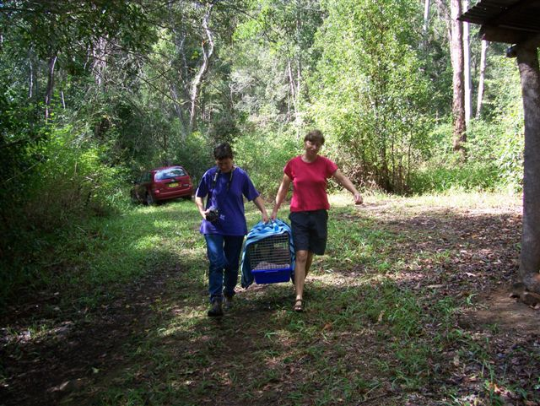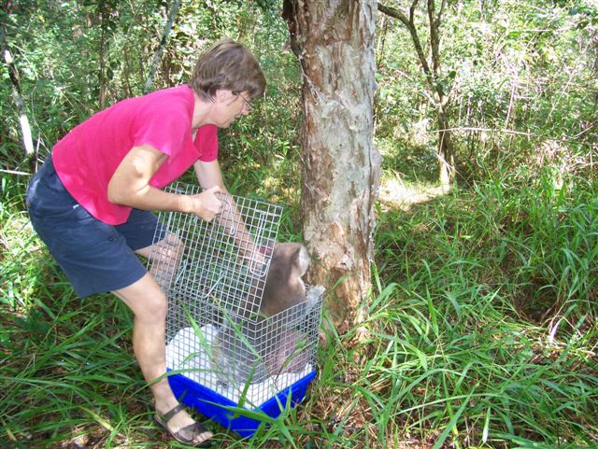

APPENDIX 7 : Byrrill Creek Wallaby Population & Vehicle Road Kill letter Shirley Ross

Shirley Ross
Byrrill Creek Rd
Terragon
10th July, 2009

To whom it may concern,

My observations are, at the beginning of Byrrill Creek Road, along the first straight stretch and around the first bend, that there are many wallabies who use this area to cross from one side to another, probably for water, and they often get hit by cars.

Over the last couple of years the wallaby population has tripled in this small area of Byrrill Creek. Mothers with joeys are seen grazing every day in our paddocks, on our neighbour’s land, and crossing the road.

In the last 6 months there have been at least 4 deaths, and in the last year, 8 to 10 deaths.
A neighbour further up the road swerved, hit a wallaby and then hit the embankment. Cars, especially P. Platers, tend to speed on this section of the road, as it is so straight.

A mother wallaby was killed recently, and the baby joey was found alive next to her, with our Kelpie guarding the joey. We took the joey to the Wild Life Carers, but it died as it was too young. My husband found this quite distressing.

I feel there needs to be some sort of signage, indicating to the public, the large amount of wallabies, and other wildlife, such as bandicoots and echidnas, which use Byrrill Creek road.

Yours Faithfully,

Mrs Shirley Ross

APPENDIX 8 (i) Byrrill Creek Vegetation & Koala Lettter Rhonda James, Ecologist
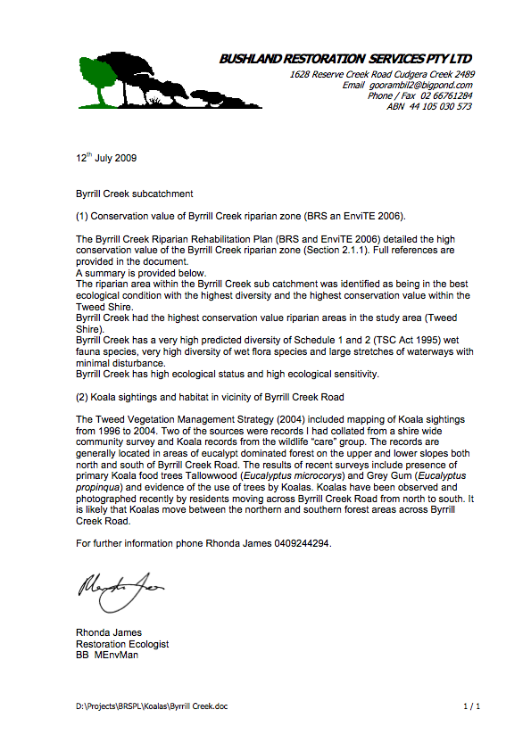

APPENDIX 8 (ii) R. James: Conservation of Iconic Species Within Priority Areas in the Tweed: Byrrill
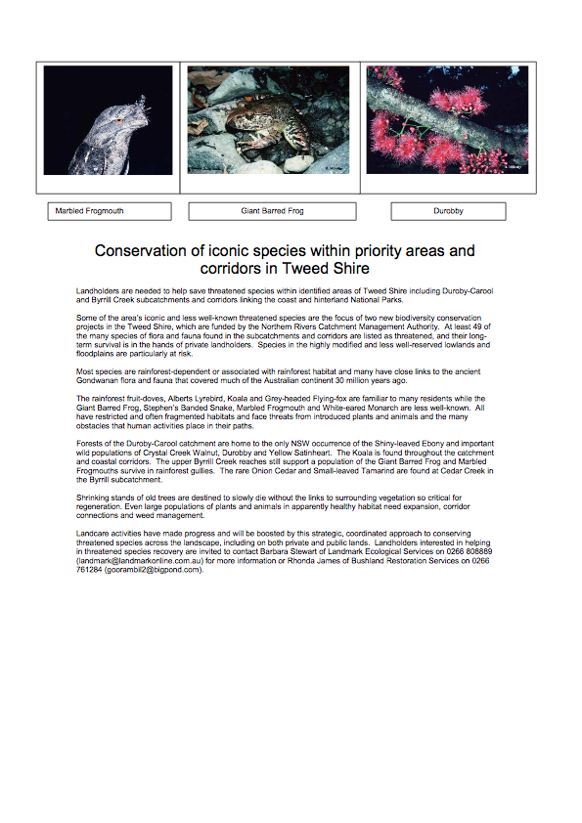

(Appendix 8 (ii) continued)
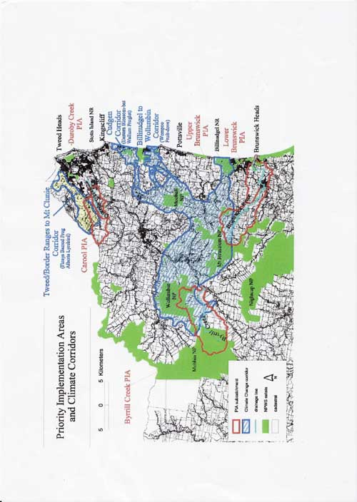

APPENDIX 8 (iii) Byrrill Creek 2006 Riparian Rehabilitation Plan Executive Summary


Byrrill Creek 2006

Riparian Rehabilitation Plan

Executive Summary

The Byrrill Creek Riparian Rehabilitation Plan has been prepared as part of the Byrrill
Creek Bank Stabilisation and Riparian Enhancement Planning Project. The Northern Rivers Catchment Management Authority contracted Environmental Training and Employment Inc. (EnviTE NSW) and Bushland Restoration Services (BRS) to manage the project, which received Australian and NSW Government funding through the Natural Heritage Trust.

The Byrrill Creek subcatchment, located in the upper reaches of the Tweed River catchment, includes Byrrill Creek and its tributaries Cedar Creek, Cabbage Creek and Kunghurloo Creek. The area has significant environmental, landscape, scientific, social and cultural values.
Much of the area adjoins National Park and State Conservation Area.

Recent reports have documented the high conservation significance of the area. A large proportion of the subcatchment is vegetated with high diversity of flora and fauna species. The area has the highest priority within the Upper Tweed for riparian restoration works due to
high conservation ecosystem values, high recovery potential streams and contribution to town water supply.

Weed invasion is the greatest threat to the vegetation communities in the Byrrill Creek subcatchment. Small-leaved Privet, Camphor Laurel and Cat’s Claw Creeper are the most significant weeds in the area. The creekbank and bed condition is generally good. Water quality testing has shown that Byrrill Creek is among sites with the highest water quality in the Tweed catchment.

The Byrrill Creek Riparian Rehabilitation Plan consists of a master document and twenty seven individual Property Action Plans prepared in partnership with each participating landholder in the Byrrill Creek subcatchment. This document provides an overview of the project including background information, riparian vegetation description, a summary of plan outcomes, prioritisation, costings and rehabilitation strategy.

Individual Property Action Plans detail the results of site assessments undertaken on participating properties. The assessment included compilation of weed and native species lists, classification of the vegetation communities in the riparian zone, creek and bank condition, management issues, photopoints and ranking for conservation significance and rehabilitation potential. Individual Property Action Plans detail planned restoration works. A works program provides estimated costs and timeframes for implementation of restoration activities.

Successful riparian rehabilitation is dependant on community involvement, understanding and ownership of the plan and its subsequent implementation. The community has been informed and extensively involved in this project. Thirty nine landowners were contacted to participate in the riparian rehabilitation project. Four landowners did not have frontage to Byrrill Creek,
six did not reply after two letters and a phone call, three owners have declined to participate in the project and twenty six indicated they would like more information or would like to participate in the project.

Participating landowners represent 74% of the total landowners who have frontage to Byrrill Creek, Cedar Creek, Kunghurloo Creek and Cabbage Tree Creek. A total of 19.37km (73%) of both banks of these creeks is included in the individual plans.

The preparation of the plan has increased landholder and community awareness and understanding of the ecological value of Byrrill Creek subcatchment. The implementation of the Byrrill Creek Riparian Rehabilitation Plan, in partnership with landholders, will result in improved management, protection and rehabilitation of riparian areas in the subcatchment.

2.1.1 Conservation Significance
The Byrrill Creek subcatchment includes Byrrill Creek, Cedar Creek (and tributaries),
Cabbage Tree Creek and Kunghurloo Creek. Adjoining National Parks and the State
Conservation Area which are part of the upper area of the subcatchment are not
included in this study. The values of vegetation communities and habitat in the Byrrill
Creek subcatchment are enhanced by proximity to these reserved areas.
The Byrrill Creek subcatchment has significant environmental, landscape, scientific,
social and cultural values. Many of the people who live in the Byrrill Creek
subcatchment have been attracted by natural environmental qualities. Recent
reports have documented the high conservation significance of the Byrrill Creek
Subcatchment. A brief outline of the findings of these reports is provided below.
The Tweed Catchment Stressed Rivers Assessment Report (August 1999) identified
􀂃 the high conservation value of Byrrill Creek subcatchment based on the:
􀂃 very high proportion of the subcatchment vegetated (83%),
􀂃 very high predicted diversity of Schedule 1 and 2 wet fauna species,
􀂃 very high diversity of wet flora species,
􀂃 large stretches of waterways with minimal disturbance, and
􀂃 large areas of Department of Environment and Conservation (DEC) estate (10%)
and State forest (40%). Note that State Forests have now been included in the
DEC estate.
Future risk considerations included:
􀂃 Byrrill Creek potential future Town Water Supply for future augmentation,
􀂃 exotic vine infestation of streamside vegetation, and
􀂃 infestation of Camphor Laurel and Privet.
The River StylesTM in the Tweed & Brunswick Catchments, North Coast NSW
(Lampert et al., 1999) report mapped the distribution of river styles in the Tweed and
Brunswick catchments. Byrrill Creek is defined as a gorge river style characterised
by a bedrock confined and floored channel with no floodplain development. The
gorge along Byrrill Creek is of moderate gradient. The confined nature of this river
style means that high stream powers can be generated. This stream is capable of
moving large gravel during even more moderate flow events. The more resistant
rocks of the central Mount Warning complex are the primary control on the presence
of this section of the gorge.
The River StylesTM (1999) report outlined the conservation goal for Byrrill Creek as
being to maintain the integrity of river structure, vegetation associations and
ecological values. The ecological values of Byrrill Creek would be enhanced by
weed management and native vegetation restoration in the riparian area. The report
noted that identification and stabilisation of suspended sediment sources (e.g. roads,
cleared slopes) will reduce water turbidity. The River StylesTM report also indicated
that this subcatchment has a high recovery potential.
The Restoration Prioritisation of High Conservation Value Riparian Lands of the
Upper and Mid Tweed River - A Preliminary Survey Using A Rapid Assessment
Approach report was prepared for Tweed Landcare Inc. by Ecosu Environmental Consultants (2003). The aim of the project was to prioritise High Conservation Value (HCV) riparian remnant sites for restoration works in six target sub-catchments of the Upper and Mid Tweed River.
Byrrill Creek had the highest conservation value riparian areas in the study area. HCV sites were determined from
the Draft Tweed Vegetation Management Strategy (2004). It is likely that additional
HCV sites occur in the subcatchment.
Byrrill Creek subcatchment was found to be in the best ecological condition with the
highest diversity and the highest conservation value. Byrrill Creek sub-catchment is
largely located within the inner ring dyke system of the extinct Mount Warning
volcano. The steep terrain has resulted in less clearing of the original vegetation
than in other areas. Some areas, including the upper catchment of Cedar Creek, are
in near pristine condition with very significant HCV vegetation and presence of
Threatened Species.
Weed invasion is the greatest threat to the vegetation communities in the Byrrill
Creek subcatchment. Small-leaved Privet, Camphor Laurel and Cat’s Claw Creeper
are the most significant weeds in the area. The riverbank and bed condition is
generally good along Byrrill Creek.

2.1.2 Value of Riparian Vegetation
Riparian land is any land that adjoins or directly influences a body of water. It
includes the land alongside small creeks and rivers, including the river bank itself and
gullies and dips which sometimes run with water. Riparian land provides a link
between land and water ecosystems. It plays an important role in the lifecycle of
many native animals and plants. Vegetation along Byrrill Creek is habitat for flora
and fauna, including threatened species.
Appropriate management of riparian land can contribute to decreased erosion,
improved water quality and healthy ecosystems (Price & Lovett, 2002). Riparian
vegetation plays a critical role in ensuring the ecological integrity of adjacent streams.
Good management of riparian land can decrease the amount of soil, nutrients and
some pollutants moving from upslope into the stream. By trapping soil and nutrients,
water quality is improved.
Riparian vegetation protects banks from surface erosion by rain, water flow or stock.
Plant roots help stabilise streambanks and protect against erosion. Healthy riparian
vegetation contains a range of species providing diversity and structure. Native
grasses and reeds, and shrubs with flexible stems and branches are often found on
the lowest parts of the bank. Further up the bank are shrubs and small trees and at
the top there may be large trees with a shrub understorey.
Byrrill Creek Riparian Rehabilitation Plan
Bushland Restoration Services (BRS) & Environmental Training and Employment Inc. EnviTE NSW 12

APPENDIX 8 (iv) Northern Rivers Catchment Management Authority Corridor Connection Plan 2009 Byrrill
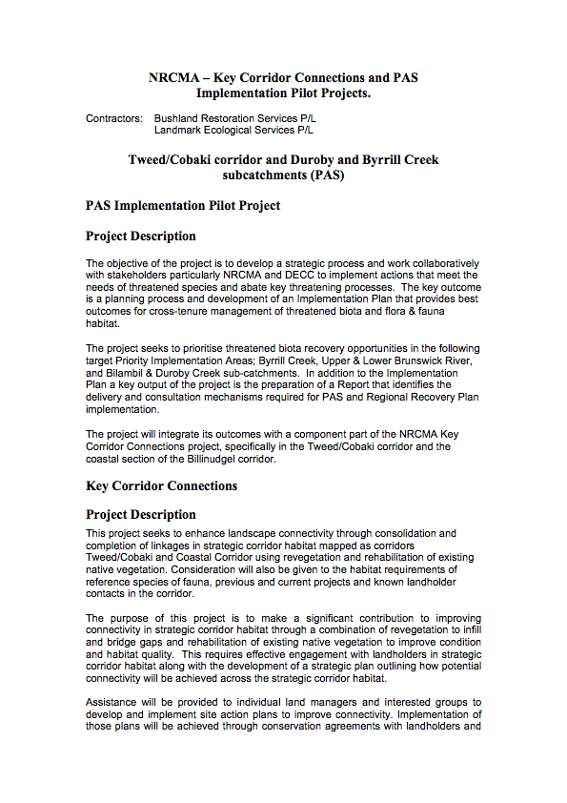
the provision of funds or on ground resources to revegetate, protect and manage native vegetaion in strategic corridor habitat – leading to improved connectivity of habitat within the landscape.

In addition, a strategic plan identifying ongoing works including a map outlining how potential connectivity will be achieved across the strategic corridor habitat will be prepared. This contract is being delivered in collaboration with the PAS Implementation Pilot Project.

APPENDIX 8 (v) R. Kooyman Wollumbin State Forest Threatened Flora Species 2000

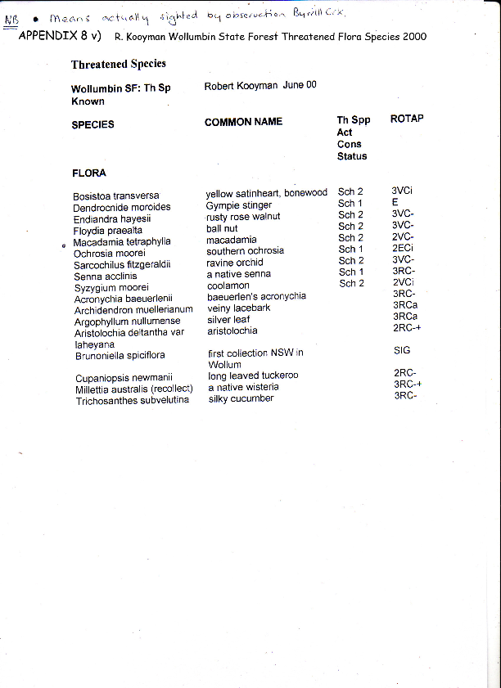

APPENDIX 9(i) National Parks & Wildlife Atlas: Byrrill Creek Koalas

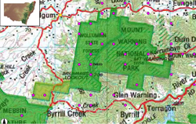

APPENDIX 9 (ii) National Parks & Wildlife Atlas: Byrrill Creek Giant Barred Frog

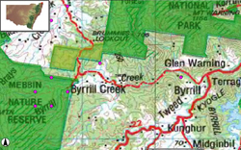

APPENDIX 9 (iii) Biolink Vegetation Types & Threatened Flora & Bird Habitat

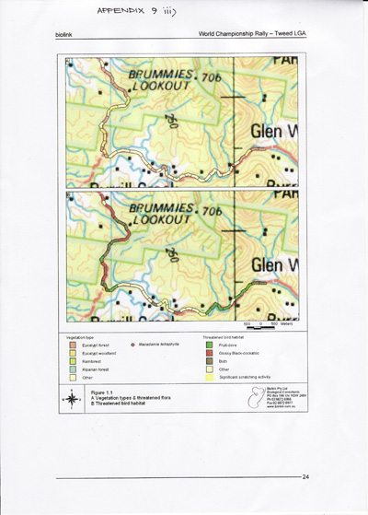

APPENDIX 9 (iv) Biolink Koala Habitat: Core & Potential

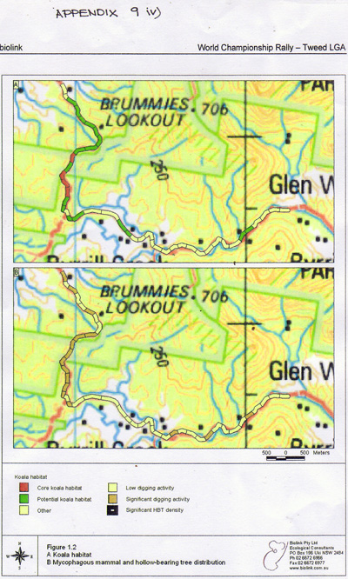

APPENDIX 9 (v) Byrrill Creek Area 2009: Sitings of Endangered, Vulnerable and other Fauna

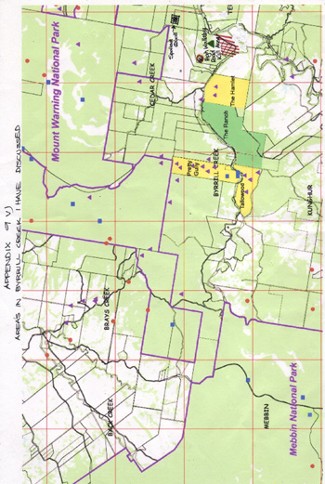

APPENDIX 9 (vi) – Byrrill Creek Area 2009: Sitings of Endangered, Vulnerable and other Fauna (same as previous map but zoomed in)

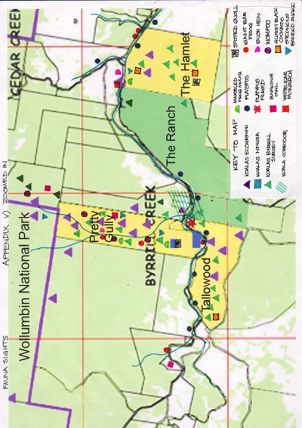

APPENDIX 9 (vii) Map: Repco Rally Route

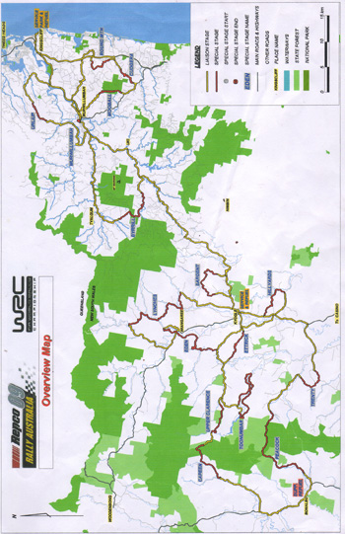

APPENDIX 10 Letter to Gary Connelly, Repco Rally Australia

To G. Connelly
Manager
Repco Rally Australia

Joanna Gardner
564 Byrrill Creek Rd
Uki NSW 2484
Email peter.symons8@bigpond.com
Phone 02 66797039

15th July, 2009

Dear Mr Connelly, Mr Upson, and Organisers of Repco Rally Australia,

I have been a resident and landholder at Byrrill Creek for 25 years. It is a bio diverse area with high conservation riparian status. It is a wild life corridor linking Mt Warning National Park, Wollumbin National Park, Wollumbin State Conservation Area and Mebbin National Park. Byrrill Creek has a high incidence of Endangered & Vulnerable Species.

I have compiled a Byrrill Creek Fauna and Flora Survey. It is a 40 page document and needs to be examined in detail.
I have found some of Steve Phillips assessments do not concur with mine. A reassessment of Byrrill Creek area needs to be carried out.

The Byrrill Creek area is not a suitable site for a high speed car rally and I request, on behalf of the residents here, that this area be removed from the Rally route.

I would appreciate a reply to this submission as soon as possible.

Yours Sincerely,

Joanna Gardner

APPENDIX 11 DVD Footage in Byrrill Creek
The following DVDs are available on request:-

i) Koala crossing Byrrill Creek Rd: 21/10/2006
ii) Koalas mating, Pretty Gully: 1/12/1999
iii) Platypus in Byrrill Lagoon: Spring 2002

Alternately, the following URL contains footage in Byrrill Creek of a koala crossing the road and highlights of platypus in Byrrill Lagoon:-
http://www.youtube.com/watch?v=-Sw18zvU5yU

