Threatened fauna of northeastern New South Wales are
at risk from Repco Rally Australia racing car rally
3-6 September 2009

by Joan E. Vickers, Toowoomba, Queensland, vickers@usq.edu.au

Table of Contents

Summary 6
Introduction 6
Maps of rally stages 6
EBPC Nationally Threatened Fauna at risk from the rally 9
Spotted-tailed Quoll (Dasyurus maculates) 9
Rally Stages 10
Status 10
Risk of adverse rally impact 10
Breeding 10
Considerations under the EPBC Act 11
Description 11
Distribution and habitat 11
Threats 11
Fleay’s Barred Frog (Mixophyes fleayi), Giant Barred Frog (Mixophyes iterates) and Stuttering Frog (Mixophyes balbus) 11
Rally Stages 12
Status 13
Risk of adverse rally impact 13
Breeding 13
Considerations under the EPBC Act 13
Descriptions 13
Distribution and habitat 14
Threats 14
Eastern Bristlebird 15
Rally Stages 15
Status 15
Risk of adverse rally impact 15
Breeding 15
Considerations under the EPBC Act 16
Description 16
Distribution and habitat 16
Threats 16
Three-toed Snake-tooth Skink (Coeranoscincus reticulatus) 17
Rally Stages 17
Status 17
Risk of adverse rally impact 17
Breeding 17
Considerations under the EPBC Act 17
Description 18
Distribution and habitat 18
Threats 18
Black-breasted Button-quail (Turnix melanogaster) 18
Rally Stages 18
Status 18
Risk of adverse rally impact 19
Breeding 19
Considerations under the EPBC Act 19
Description 19
Distribution and habitat 19
Threats 19
Red Goshawk (Erythrotriorchis radiatus) 20
Rally Stages 20
Status 20
Risk of adverse rally impact 20
Breeding 20
Considerations under the EPBC Act 20
Description 21
Distribution and habitat 21
Threats 21
Albert’s Lyrebird (Menura alberti) 21
Rally Stages 21
Status 22
Risk of adverse rally impact 22
Breeding 22
Considerations under the EPBC Act 22
Description 22
Distribution and habitat 22
Threats 22
Long-nosed Potoroo (Potorous tridactylus) 23
Rally Stages 23
Status 23
Risk of adverse rally impact 23
Breeding 23
Considerations under the EPBC Act 24
Description 24
Distribution and habitat 24
Threats 24
Grey-headed Flying-fox (Pteropus poliocephalus) 24
Rally Stages 25
Status 25
Risk of adverse rally impact 25
Breeding 25
Considerations under the EPBC Act 25
Description 25
Distribution and habitat 25
Threats 25
Large-eared Pied Bat (Chalinolobus dwyeri) 26
Rally Stages 26
Status 26
Risk of adverse rally impact 26
Breeding 26
Considerations under the EPBC Act 26
Description 26
Distribution and habitat 26
Threats 27
NSW Threatened Fauna described as at risk from Repco Rally Australia (Biolink 2009a, b) 27
Koala (Phascolarctos cinereus ) 27
Rally Stages 28
Status 28
Risk of adverse rally impact 28
Breeding 29
Description 29
Distribution and habitat 29
Threats 29
Red-legged Pademelon (Thylogale stigmatica) 29
Rally Stages 30
Status 30
Breeding 30
Risk of adverse rally impact 30
Description 30
Distribution and habitat 30
Threats 30
Yellow-bellied Glider (Petaurus australis ) 31
Rally Stages 31
Status 31
Breeding 31
Risk of adverse rally impact 31
Description 31
Distribution and habitat 32
Threats 32
Red-tailed Black Cockatoo (Calyptorhynchus banksii) 32
Rally Stages 32
Status 32
Risk of adverse rally impact 33
Breeding 33
Description 33
Distribution and habitat 33
Threats 33
Glossy Black Cockatoo (Calyptorhynchus lathami) 33
Rally Stages 34
Status 34
Risk of adverse rally impact 34
Breeding 34
Description 34
Distribution and habitat 34
Threats 34
Rose-crowned Fruit Dove (Ptilinopus regina) and Superb Fruit Dove (Ptilinopus superbus) 35
Rally Stages 35
Status 36
Risk of adverse rally impact 36
Breeding 36
Description 36
Distribution and habitat 36
Threats 37
White-eared Monarch (Monarcha leucotis) 37
Rally Stages 37
Status 37
Risk of adverse rally impact 37
Breeding 38
Description 38
Distribution and habitat 38
Threats 38
Olive Whistler (Pachycephala olivacea) 38
Rally Stages 38
Status 39
Risk of adverse rally impact 39
Breeding 39
Description 39
Distribution and habitat 39
Threats 39
Brown Tree Creeper (Climacteris picumnus) 40
Rally Stages 40
Status 40
Risk of adverse rally impact 40
Breeding 40
Description 40
Distribution and habitat 41
Threats 41
Grey-crowned Babbler (Pomatostomus temporalis) 41
Rally Stages 41
Status 41
Risk of adverse rally impact 42
Breeding 42
Description 42
Distribution and habitat 42
Threats 42
EPBC Nationally threatened fauna within 5 km not described as at risk from rally 43
Brush-tailed Rock Wallaby (Petrogale penicillata) 43
Rally Stages 43
Status 43
Breeding 43
Description 43
Distribution and habitat 44
Threats 44
NSW threatened fauna within 5 km not described as at risk from rally 44
Squirrel Glider (Petaurus norfolcensis ) 44
Rally Stages 44
Status 45
Breeding 45
Description 45
Distribution and habitat 45
Threats 45
Brush-tailed Phascogale (Phascogale tapoatafa) 45
Rally Stages 46
Status 46
Breeding 46
Description 46
Distribution and habitat 46
Threats 46
Additional NSW threatened fauna within 5 km of rally stages 46
Discussion 47
Conclusion 48
Photo credits 48
References 50

Summary
This report profiles twelve nationally threatened fauna species, and eleven species threatened in NSW that are at risk from activities of Repco Rally Australia. In addition, one nationally threatened species and two NSW threatened species within 5 km of rally stages that are not described as at risk from the rally are profiled. Rally stages in which each species occurs and conservation status are noted. The risk of adverse rally activity as assessed in the Ecological Assessments commissioned by Repco Rally Australia (Biolink, 2009a, 2009b), and in two critiques of the Biolink reports (Ambrose, 2009; Graham, 2009) is described. For the nationally threatened species, views in the four reports regarding referral of the Repco Rally Australia proposal to the Commonwealth Minister for the Environment are summarized. A short description is provided for identification, and the breeding cycle, distribution, habitat and common threats are briefly outlined for each species. Fifty additional fauna species threatened in NSW that occur within 5 km of rally stages are listed. The conclusion is that the Repco Rally Australia should not be conducted in an area where so many threatened species will be put at risk.

Introduction

Here we profile threatened fauna at risk from the Repco Rally Australia motor car race, proposed to be held in Tweed and Kyogle Shires in northeastern New South Wales. NSW threatened flora occurring close to each stage have been noted in (Biolink, 2009a, 2009b), and nationally threatened fauna in the two Biolink reports and in two independent critiques of the reports (Ambrose, 2009) and (Graham, 2009). NSW threatened species are listed in the Threatened Species Conservation Act (1995), and nationally threatened species in the Environmental Protection and Biodiversity Conservation (EPBC) Act: The area of northeastern New South Wales through which the rally is proposed to run is recognized as a high biodiversity area of Australia. The Border Ranges (just west of the Byrrill stage) comprise one of Australia’s 15 National Biodiversity Hotspots (Australian Government, 2009). Two rally stages pass through areas of Toonumbar National Park which contains Gondwana temperate rainforests that are World Heritage listed (UNESCO, 2009).

Maps of rally stages

The following two maps show the locations of the rally stages in Tweed and Kyogle Local Government Areas (LGAs).
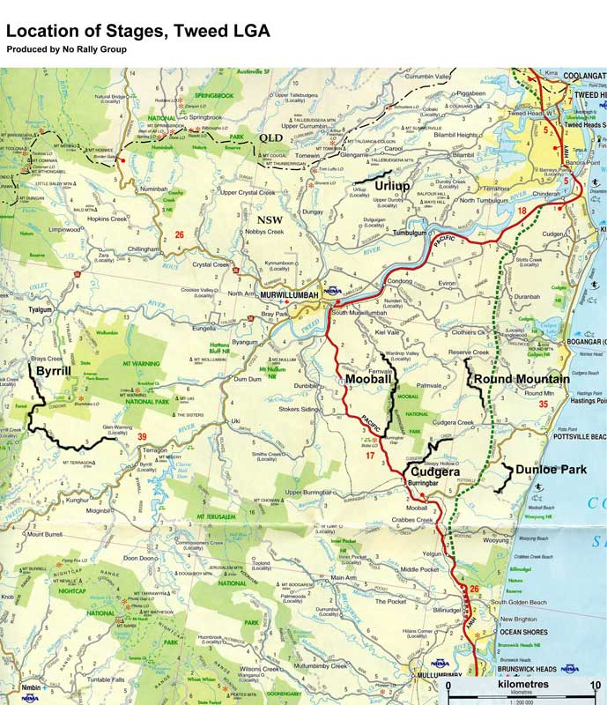

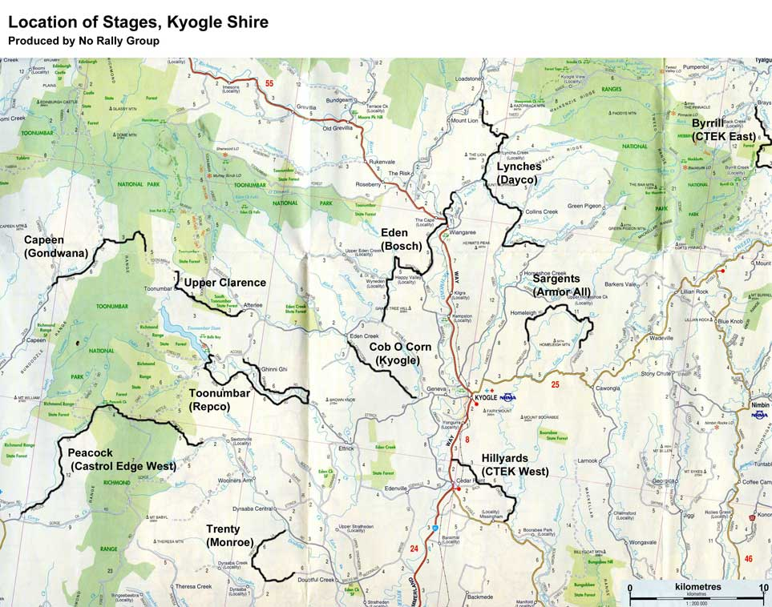

EBPC Nationally Threatened Fauna at risk from the rally
According to EPBC Act, threatened species are matters of national environmental significance, and are significantly impacted upon by a development proposal if it is likely to (terminology for vulnerable species in brackets):
- lead to a long-term decrease in the size of a (an important) population; or
- reduce the area of occupancy of a species; or
- fragment an existing population into two or more (important) populations; or
- adversely affect habitat critical to the survival of a species; or
- disrupt the breeding cycle of a (an important) population; or
- modify, destroy, remove, isolate or decrease the availability or quality of habitat to the extent that the species is likely to decline; or
- result in invasive species that are harmful to a endangered (vulnerable) species becoming established in the endangered (vulnerable) species’ habitat; or
- interfere substantially with the recovery of a species.

If the threatened species is likely to be significantly impacted, then the proposal must be submitted to the Commonwealth Minister for the Environment for approval.

Risk categories are High, Medium and Low Likelihood of presence/Likelihood of motor vehicle strike (eg. H/M) (Biolink, 2009a, 2009b).

Spotted-tailed Quoll (Dasyurus maculates)

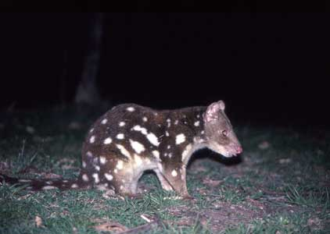
Spotted-tailed Quoll, Pat McConnell, Goomburra State Forest
Near Allora, Queensland, about 1998.

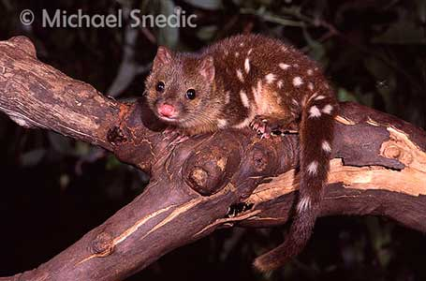
Spotted-tailed Quoll, juvenile.

Rally Stages

The Spotted-tailed Quoll occurs within 5 km of Tweed stages Byrrill, Dunloe, Mooball and Urliup, and 1 km of Cudgera and Round Mountain and in Kyogle stages within 5 km of Capeen, Cob O Corn, Eden, Lynches and Sargents and 1 km of Toonumbar, Trenty and Upper Clarence (NSWNPWS Wildlife Atlas, cited in (Biolink, 2009a, 2009b)).

Status
Vulnerable in NSW, nationally Endangered

Risk of adverse rally impact
The Biolink Ecological Assessments describe the Spotted-tailed Quoll as H/M in Tweed stages Cudgera and Round Mountain and M/L in Byrrill, Dunloe, Mooball and Urliup, and at H/M in Kyolge stages Cob O Corn, Toonumbar, Peacock and Upper Clarence and M/L risk in Capeen, Eden, Lynches and Sargents. The Spotted-tailed Quoll is described as problematic in terms of amelioration. In other words, there is a risk to the Spotted-tailed Quoll in all of these stages and nothing can be done to counter the risk.

Breeding
Mating occurs in mid-June, young are born in July and are not independent until November (Australian_Government_Natural_Heritage_Trust & WWF_Australia). Juvenile quolls will be present at rally time.

Considerations under the EPBC Act
Biolink (2000c) concluded that because the Spotted-tailed Quoll can be diurnal, the rally had the potential to reduce the area of occupancy for the species and disrupt the breeding cycle in the Urliup stage. This conclusion comprises sufficient grounds to refer the rally plan to the Federal Environment Minister for approval (Ambrose, 2009) (a recommendation also made in the Biolink report). At other stages as well, a reduction in area of occupancy, disruption of the breeding cycle and habitat destruction are likely to lead to a long term decline in population numbers, and this scavenger will be attracted by road kill likely to happen at the rally, and become road kill itself (Graham, 2009).

Description
Largest marsupial carnivore on Australian mainland (75 cm long), rich chocolate brown fur with white spots on tail and body. Eats insects, birds, small wallabies, carrion (DEC, 2005n; Warringa_Council)

Distribution and habitat
Southeast mainland: Queensalnd (E), NSW (V), ACT (V), SA (E), TAS (Rare). Range of habitats from coast to snowline.

Threats
Feral animals, cats, destruction of habitat by urban expansion.

Fleay’s Barred Frog (Mixophyes fleayi), Giant Barred Frog (Mixophyes iterates) and Stuttering Frog (Mixophyes balbus)
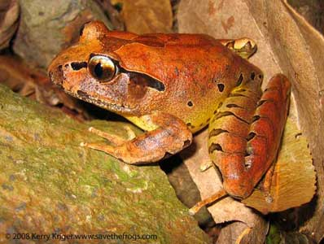
Fleay’s Barred Frog – Endangered

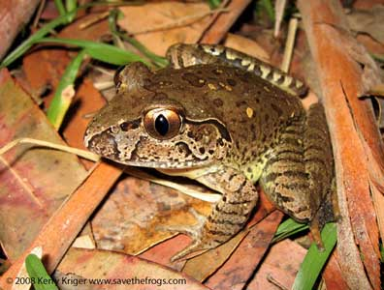
Giant Barred Frog – Endangered

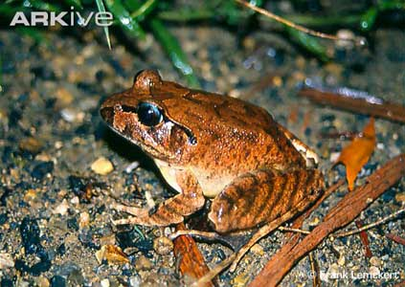
Stuttering Frog - Vulnerable

Rally Stages
(NSWNPWS Wildlife Atlas)
Giant Barred Frog occurs within 5 km of Byrrill and Peacock stages.
Fleay’s Barred Frog occurs within 5 km of Capeen stage. There is a population at Byrrill Creek also (Graham, 2009). Stuttering Frog occurs within 5 km of Byrrill.

Status
Giant Barred Frog – Endangered in NSW and nationally
Fleay’s Barred Frog – Endangered in NSW and nationally
Stuttering Frog – Endangered in NSW and nationally Vulnerable

Risk of adverse rally impact
Risk is described as H/H for Peacock and H/M for Byrrill and Capeen stages because the populations of all three species are located at and/or downstream of the water crossing (Biolink, 2009a, 2009b). Risks are considered to be fuel/oil spills, with pollution barriers (of unspecified nature) to be placed downstream as an amelioration measure. Clearly these barriers are not going to protect populations immediately at the water crossings.

Breeding
The rally corresponds with the beginning of the breeding season (September to February) for these endangered and vulnerable frogs (Ambrose, 2009; Biolink, 2009a, 2009b; Graham, 2009). Tadpoles, metamorphs and/or juvenile frogs will be in the water. Biolink claims no disruption of the breeding cycle, while Graham (2009) says “likelihood of significant disruption to the breeding cycle…is very high”. Ambrose (2009) predict additional impacts from habitat degradation due to settlement of airborne soils and dust, runoff of sediment and oil/tyre residues from the road and notes that eggs and tadpoles are highly vulnerable to these pollutants which are likely to accumulate over the ten years of the rally. Also, chytrid fungus (deadly to frogs) is likely to be brought in on spectators’ muddy boots and tyres and subsequently being carried into frog habitat.

Considerations under the EPBC Act
Biolink (2000c) concluded that there was no impact under any of the EPBC Act impact categories, but Ambrose (2009) and Graham (2009) agree that the rally would impact the endangered and vulnerable frog populations by reducing the area of occupancy of the species, disrupting the breeding cycle and modifying, destroying, removing or decreasing the availability of quality of habitat to the extent that the species is likely to decline.

Descriptions
(DEC, 2005d, 2005e, 2005p)

Fleay’s Barred frog
Moderate to large frogs, to 90 mm. Medium to pale brown above, Iris silver blue upper and brown lower. Narrow barring across limbs.

Giant Barred Frog
Large frogs to 115 mm. Olive to dark brown above, paler below. Vertical pupil. Iris pale golden above, brown below. Black thighs with small yellow spots, distinct barring, dark blotches.

Stuttering Frog
Large, 80 mm. Large black eyes, vertical pupils. Webbed feet, barred hid legs, black line from snout through eye and above ear. Brown to olive great above and creamy white below. Pale blue crescent upper half of eye. Tadpole dark brown to black. East coast of Australia, southern Queensland to eastern Victoria. Marked decline, south east NSW. Rainforest and wet, tall open forest, east side of range. Deep leaf litter and thick understory. Feed on insects, smaller frogs. Tadpoles take 12 months to metamorphose.

Distribution and habitat

Fleay’s Barred frog
Restricted, eastern side of ranges, southeast Queensland and northeast NSW, rainforest and wet eucalypt forest.

Giant Barred Frog
Coast and ranges, southeastern Queensland to Hawksbury River in NSW.Deep, damp leaf litter in rainforests and dry eucalypt forest. Tadpoles take 14 months before metamorphosing into a frog. Feed on large insects, spiders.

Stuttering Frog
East coast of Australia, southern Queensland to northeastern Victoria. Marked decline in southeast NSW. Rainforest and wet, tall open forest eastern side of Divide. Eats insects and smaller frogs. Tadpoles metamorphose after 12 months.

Threats
All three species are threatened by clearing and fragmentation of habitat, reduction in water quality by sedimentation or pollution, changes in water flow, burning of leaf litter and log cover, forestry, herbicides, chytrid fungus.

Eastern Bristlebird

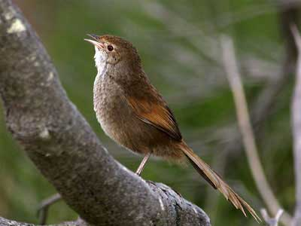
Eastern Bristlebird

Rally Stages

Biolink (2009b) lists the endangered Eastern Bristlebird as occurring within 5 km of the Lynches stage (NSWNPWS Wildlife Atlas).

Status
Endangered in NSW (extremely – only 35 birds are known to exist in the Queensland/NSW border area (Ambrose, 2009)), and Endangered nationally.

Risk of adverse rally impact
Biolink (2009b) does not list the Eastern Bristlebird as at risk of adverse impact, but Ambrose (2009) describes the bird as secretive and hard to detect, and readily detectable only during the breeding season (September to January) when they are active, inquisitive and less timid. Thus bristlebirds living close to the rally stages may not have been seen during the Biolink survey, conducted in autumn. They have small territories hence any birds living close to the stages is more likely to become road kill compared to a bid with a large range. It is very important to avoid any disturbance since the Eastern Bristlebird is so acutely endangered (Ambrose, 2009).

Breeding
(Ambrose, 2009)
As September is the beginning of the breeding season, Eastern Bristlebirds are likely to be sitting on eggs. Like other birds, they readily desert their nests when disturbed, hence the noise of low-flying helicopters, spectators and racing cars may well cause them to desert their nests.

Considerations under the EPBC Act
(Ambrose, 2009)
These rally activities therefore have the potential to significantly impact the Eastern Bristlebird by leading to a long term decrease in the size of the population and disrupting the breeding cycle of the population. It is therefore mandatory to refer the rally proposal to the Federal Environment Minister for approval.

Description
(DEC, 2005c)
Medium sized, long-tailed, brown and rufous bird. Dull brownish above, lighter grey below, rufous wings, 21 cm, with short, rounded wings. Pale face, bright red eye, bristles at base of bill.

Distribution and habitat
Southern Queensland/northern NSW, and the Illawarra Region close to the NSW/Victorian border. Total population size of about 2000 individuals in total area of about square 120 km. Four populations in Southern Queensland/northern NSW, total 35 birds. Fifteen years ago there were 154 birds in 14 populations. The Illawarra population has 1600 birds. Habitat is dense, low vegetation with heath understory, or in northern NSW open forest with tussock understory. Northern NSW birds are usually found in habitats burnt 5 to 10 years ago. Semi-flightless; rarely flies – may perch transiently as high as 1m then retreat into dense undergrowth.

Threats
Extensive and intense fire, too frequent fires, or lack of fires for more than ten years. Habitat loss, predation by cats and foxes, road kill, grazing aand trampling by livestock and invasion of weeds.

Three-toed Snake-tooth Skink (Coeranoscincus reticulatus)

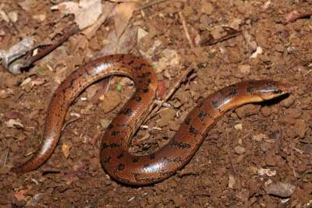
Three-toed Snake-toothed Skink

Rally Stages

This skink was not considered in Biolink (2009b), although potential habitat exists in the Capeen (Richmond Range National Park) and Peacock rally stages (Ambrose, 2009).

Status
Vulnerable in NSW and nationally.

Risk of adverse rally impact
Risks include increased road kill, destruction of road edge habitat during road works in Richmond Range National Park and weed invasion during road works (Ambrose, 2009; Graham, 2009).

Breeding
No information found.

Considerations under the EPBC Act
This skink is important because it is nationally vulnerable. Potential significant rally impacts are reduced area of occupancy of an important population, destroying (etc.) availability or quality of habitat to the extent that the species is likely to decline and harmful invasive species becoming established in the vulnerable species’ habitat (Ambrose, 2009), hence the rally proposal must be referred to the Federal Environment Minister for approval.

Description
(DEC, 2005 )
Large burrowing lizard, 23 cm, thick long tail, 4 very short legs each with 3 clawed toes. Long, curved teeth. Fawn to brown body colour. Seldom seen because of its burrowing.

Distribution and habitat
Coast and ranges from Macleay valley in NSW to southeastern Queensland. Rainforest and occasionally moist eucalypt forest, loamy or sandy soils. Lives in loose soil, leaf litter and rotting logs.

Threats
Clearing of habitat, fire, loss of leaf litter and compaction of soil by grazing by stock.

Black-breasted Button-quail (Turnix melanogaster)

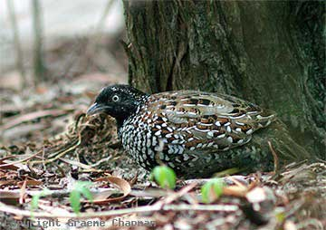
Black-breasted Button-quail

Rally Stages

The Black-breasted Button-quail occurs within 5 km of Tweed stages Byrrill stage (NSWNPWS Wildlife Atlas), which supports one of the highest concentrations of observations for this species in NSW (Graham, 2009).

Status
Endangered in NSW, nationally Vulnerable

Risk of adverse rally impact
Biolink (2009a) considered that the rally would have no impact on Byrrill stage Black-breasted Button-quails. Ambrose (2009) notes that like the Eastern Bristlebird, the Black-breasted Button-quail is a poor flyer, may cross tracks and may be nesting close to the road resulting in increased road kill. This bird is a ground forager and flies at low levels when disturbed, hence the risk of road strike is greatly increased (Graham, 2009). Biolink (2009a) considered that in case of impact, amelioration would be problematic.

Breeding
The breeding season is September to April, so these birds will be nesting at rally time. They have small ranges of about 1.5 ha, so there is a significant risk that nests of populations close to the rally stage will be deserted as a result of rally disturbance (Ambrose, 2009).

Considerations under the EPBC Act
Significant impacts would be reduced area of occupancy and disruption of the breeding cycle of an important population (Ambrose, 2009), and Graham (2009) adds “modify, destroy , remove or isolate or decrease the availablility or quality of habitat to the extent that the species is likely to decline” to the list. Hence the rally must be referred to the Federal Environment Minister for approval.

Description
(Wikipedia, 2008)
Plump quail-shaped bird but not a quail. Marbled black, rufous, pale brown and white plumage, female larger than male with more extensive black face and chin. Up to 20 cm.

Distribution and habitat
Hervey Bay in Queensland to northeastern corner of NSW. Rare, with a fragmented populations. Rainforest and nearby areas, and Hoop Pine plantations and lantana thickets. Only 5000 birds and declining. Female has multiple male partners, while male incubates the egg.

Threats
(Birdlife_International, 2009b)
Ninety percent of its habitat has been cleared for agriculture or hoop pine plantations. Timber harvesting. Grazing and disturbance by cattle, horses, feral pigs and wallabies which have increased in number following learing. Feral cats and foxes.

Red Goshawk (Erythrotriorchis radiatus)

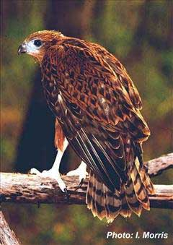
Red Goshawk

Rally Stages

The Red Goshawk occurs within 5 km of Tweed stages Cudgera and Mooball (1 km) and in Kyogle stage Eden (NSWNPWS Wildlife Atlas).

Status
Endangered in NSW, Vulnerable nationally. Biolink (2009a, b) and Graham (2009) do not consider this bird.

Risk of adverse rally impact
Because of its extensive range across northern Australia, the Red Goshawk would not be threatened nationally by the rally, but since it is rare in NSW, Ambrose (2009) recommends a search for Red Goshawk nests prior to the onset of the race and that if found the stage should not be used.

Breeding
The start of the breeding season corresponds with the rally (Ambrose, 2009).

Considerations under the EPBC Act
No significant impact on national status of the species under the EPBC Act.

Description
(Australian_Government_DEWHA, 2009)
Swift, powerful rufous brown hawk 45 – 60 cm. Females larger. Mottled and streaked, under parts brighter, yellowish legs and feet. Six-fingered wings, heavy dark streaking on head and chest.

Distribution and habitat
(Australian_Government_DEWHA, 2009)
Solitary and very thinly dispersed. Coastal and subcoastal from western Kimberley to northern NSW. Only 330 breeding pairs. Wooded and forested lands of tropical and warm temperate Australia. In NSW, subtropical rainforest and Melaleuca forest along coastal rivers.

Threats
(Australian_Government_DEWHA, 2009)
Habitat loss, widespread deforestation.

Albert’s Lyrebird (Menura alberti)
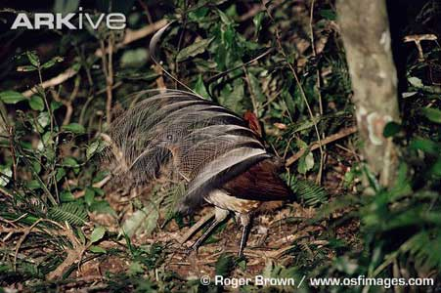
Albert’s Lyrebird

Rally Stages

Albert’s Lyrebird occurs within 5 km of Tweed stages Byrrill and Urliup, and Kyogle stages Capeen, Hillyards, Lynches, Peacock and Upper Clarence (NSWNPWS Wildlife Atlas,cited in (Biolink, 2009a, 2009b).

Status
Vulnerable in NSW, not listed on EPBC Act (not considered under EPBC in Biolink (2009a or b)) but listed as Vulnerable by IUCN Red List 2006.

Risk of adverse rally impact
The Biolink Ecological Assessments list Albert’s Lyrebird at H/M risk in Tweed stages Byrrill, Cudgera, Round Mountain and Urliup and in Kyogle stages Capeen, Peacock and and Upper Clarence.

Breeding
Albert’s Lyrebirds breed from May to September, so young birds and some nesting sites could still be present at rally time.

Considerations under the EPBC Act
Not considered by Biolink (2000a or b). Ambrose (2009) and Graham (2009) agree that the rally traverses areas that are important to the national status of Albert’s Lyrebird, as locations of important populations or wildlife corridors, at the Urliup, Byrrill, Clarence, Capeen and Peacock stages. Increased road kills are likely to result due to this species’ tendency to run along the edge of the road, and juveniles present at this time of year would not yet have learned to avoid cars. This would result in reduced area of occupancy of an important population. In addition, trampling of good quality habitat would lead to habitat destruction (etc.) to the extent that the species is likely to decline.

Description
(Birdlife_International, 2009a)
Rufous and chestnut pheasant-like birds with long tail. Chestnu upper parts, rufous throat, foreneck and undertail. Male tail glossy black above and silver-grey below. Total population 3,500 and decreasing.

Distribution and habitat
Confined to relatively small area of rainforest between Blackwall Range, NSW and Mistake Range, Queensland. 800 pairs in NSW. Tweed, McPherson and Richmond Ranges have important subpopulations. Moist forest mostly above 300m, deep leaf litter, Antarctic beech and wet sclerophyll forests.

Threats
Habitat clearance, lantana in disturbed areas, fragmentation into very small populations, fire.

Long-nosed Potoroo (Potorous tridactylus)
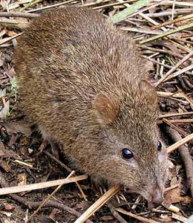
Long-nosed Potoroo

Rally Stages

The Long-nosed Potoroo occurs within 5 km of Kyogle stages Capeen, Hillyards, Peacock, Toonumbar (1 km) and Upper Clarence (1 km) (NSWNPWS Wildlife Atlas, cited in (Biolink, 2009a, 2009b)).

Status
Vulnerable in NSW and nationally

Risk of adverse rally impact
No adverse impact is noted in Biolink (2009b). However, Ambrose (2009) and Graham (2009) agree that Toonumbar and Capeen stages pass through good quality habitat where this species is known to occur, and the Upper Clarence and Peacock stages are potential habitat or adjacent to areas where this species lives. Some of this area may also act as a corridor to a well-known important population to the east.

Breeding
Breeding peaks occur late winter to early summer, with one young born.

Considerations under the EPBC Act
Increased road kill and fragmentation of habitat by building of a new road for the Capeen stage have potential to reduce the area of occupancy of an important population, weeds introduced by rally activities could interfere with the fungal fruiting bodies that the Lon-nosed Potoroo feeds on, resulting in invasive species that are harmful to a vulnerable species becoming established in the vulnerable species’ habitat. Load rally noises, road kill and general physiological stress can be expected to interfere with the species’ breeding cycle as is typical of macropods (Ambrose, 2009; Graham, 2009).

Description
(DEC, 2005j)
Weight 1.6 kg, length 360 mm, tail 200 – 260 mm. Greyish-brown above and light grey below. Similar to Long-footed Potoroo but smaller, short tail, smaller hind-foot, no leathery pad on sole of foot.

Distribution and habitat
Southeast coast of Australia from Queensland to Tasmania. Restricted to coastal heaths and sclerophyll forests east of Divide in NSW, where annual rainfall is greater than 760 mm. Needs occasional open areas. Eats fruiting bodies of hypogenous (underground fruiting) fungi, roots, soil invertebrates.

Threats
Habitat loss, predation by foxes, dogs, cats, fires, logging.

Grey-headed Flying-fox (Pteropus poliocephalus)
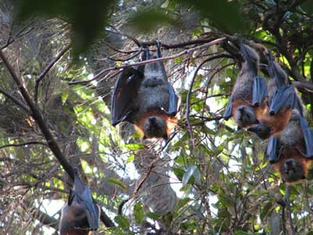
Grey-headed Flying Fox

Rally Stages

The Grey-headed Flying Fox occurs within 5 km of Tweed stages Byrrill and Urliup, and Kyogle stages Cob O Corn, Peacock and Toonumbar ) (NSWNPWS Wildlife Atlas, cited in (Biolink, 2009a, 2009b)).

Status
Vulnerable in NSW and nationally

Risk of adverse rally impact
Biolink does not consider any adverse impacts for this species. Ambrose (2009) and Graham (2009) note the Bray Park maternity camp, one of only three in the Tweed LGA, 300 m from Murwillumbah where there will be a rally stage. Noise and rally activities in September, early in the lactating period may cause mothers to abandon their young. Their breeding cycle has probably already been disturbed by earlier rally-related activities (Ambrose, 2009).

Breeding
Pregnancy occurs May to July and lactation from September to November.

Considerations under the EPBC Act
Biolink found no significant impacts. Ambrose (2009) and Graham (2009) consider that the rally will disrupt the breeding cycle of an important population and this is cause for referral to the Commonwealth Minister for the Environment.

Description
(DEC, 2005h)
Largest Australian bat, 23 – 29 cm. Dark grey body, light grey head, russet collar. Wing membranes black, wing span up to 1m. Leg fur extends to ankle, unlike other bats.

Distribution and habitat
Within 200 km of coast, Bundaberg to Melbourne. Within 20 km of regular food source, in gullies, close to water, in dense canopy. Tens of thousands can be in camps, some used for up to 100 years. Feed on nectar and pollen of native trees.

Threats
Loss of foraging habitat, disturbance of roosting sites.

Large-eared Pied Bat (Chalinolobus dwyeri)
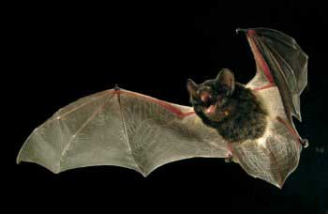
Large-eared Pied Bat

Rally Stages

The Large-eared Pied Bat occurs within 5 km of Tweed stage Byrrill (NSWNPWS Wildlife Atlas).

Status
Vulnerable in NSW and nationally.

Risk of adverse rally impact
There is no evident risk of the rally to this species (Ambrose, 2009; Biolink, 2009b).

Breeding
Young raised November through January (DEC, 2005i).

Considerations under the EPBC Act
No considerations under this Act.

Description
(DEC, 2005i)
Small to medium size, long, prominent ears, glossy black fur. Lower body has broad white fringes under wings meeting in V. A wattled bat – small lobes of skin between ears and mouth. Maneuverable flight.

Distribution and habitat
(DEC, 2005i)
Areas with cliffs and caves, Rockhampton to NSW Highlands. Roosts in caves, mud nests of Fairy Martin. Low to mid-elevation dry open forest and woodland.

Threats
Clearing of forest near cliffs, loss of foraging, close to cliffs, damage to roosting sites by mining, pesticides.

NSW Threatened Fauna described as at risk from Repco Rally Australia (Biolink 2009a, b)

Koala (Phascolarctos cinereus )

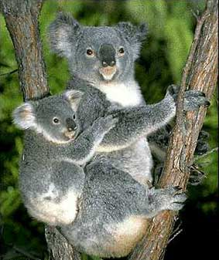
Koala and baby

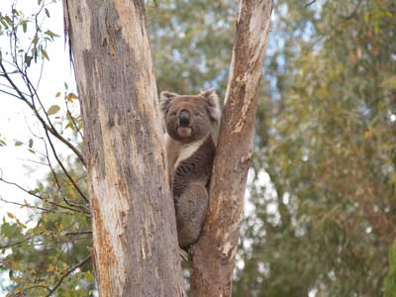
Koala, Pat McConnell.

Rally Stages
The Koala occurs within 1 km of all Tweed rally stages (Byrrill, Cudgera, Dunloe, Mooball, Round Mountain and Urliup) and Kyogle stages
Capeen, Eden, Lynches, Peacock , Sargents, Toonumbar and Upper Clarence, and within 5 km of Kyogle stage Cob O Corn (NSWNPWS), cited in Biolink (2009a, b).

Status
Vulnerable (NSW)

Risk of adverse rally impact
The Biolink Ecological Assessments list the Koala at M/M risk in all Tweed stages (Byrrill, Cudgera, Dunloe, Mooball, with core koala habitat present in all but Urliup, and at M/M risk also in Kyogle stages Capeen, Cob O Corn, Eden, Lynches, Peacock, Sargents, Toonumbar and Upper Clarence, with six stages having core koala habitat. Amelioration measures (measures to circumvent the risk), such as fences and volunteer koala guardians, are described (Biolink, 2009c, 2009d). The Koala Management Plans estimates that 15 Koalas are at risk of being killed on Tweed stages during the rally, and 26 Koalas on Kyogle stages, a total of 41 koalas. This estimate does not account for unborn koalas already conceived, or baby koalas that would have been born to female koalas had they lived to breed, or the impact of biannual rallies of the remaining nine years. Furthermore, it does not include koalas that may be killed by rally drivers driving on the route to become familiar with it before the race, or copycat drivers, who may be traveling at night, greatly increasing numbers of koalas that become road kill. Koala populations are in serious decline according to the Australian Koala Foundation (https://www.savethekoala.com/), and it is likely that this increased death rate will increase the rate of decline over this period of time.

Breeding
One young per year. Breeding season from September to March (TheKoala, 2008). The rally is at the start of the Koala breeding season.

Description
(Wikipedia, 2009b)
Thickset arboreal marsupial herbivore, Australian icon. Sharp claws for climbing, opposable thumb, fingerprints similar to humans. Lives entirely on eucalyptus leaves. Low metabolic rate, rests and sleeps 16 – 18 hours per day.

Distribution and habitat
Coastal regions of eastern and southern Australia, Adelaide to southern
Cape York Peninsula and inland moist woodland. Males 12 kg, females 8.5 kg (NSW).Wet gullies. Feed on fruits, young seedling leaves and stems, fungi, ferns.

Threats
Habitat loss, dog attacks, traffic accidents, chlamydia. Requires large areas of healthy, connected forest. Urbanization of coastal areas cuts corridors, isolating colonies

Red-legged Pademelon (Thylogale stigmatica)

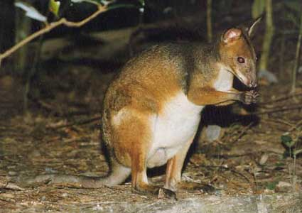
Red-legged Pademelon

Rally Stages
Red-legged Pademelon occurs within 5 km of Tweed stages Byrrill, Cudgera, Mooball and Round Mountain, and Kyogle stages Capeen and Peacock (NSWNPWS), cited in (Biolink, 2009a, 2009b; UNESCO, 2009).

Status
Vulnerable (NSW)

Breeding
Breeding is continuous. Immature Red-legged Pademelons will be present at rally time.

Risk of adverse rally impact
Reported for Tweed stages Byrrill, Cudgera, Mooball and Round Mountain, and Kyogle stages Capeen and Peacock and considered to be problematic in terms of amelioration. Road strike is likely to occur (Biolink, 2009a, 2009b). Risk was recorded as M/L for all stages except Peacock were it was H/M.
.

Description
(DEC, 2005l)
Small, compact; soft, thick fur grey-brown above, rufous brown on face, forearms, flanks and hind legs; shot, thick tail.

Distribution and habitat
Coastal and subcoastal eastern Australia, patchy. Rainforest, moist eucalypt forest and vine scrub, dense under story and ground cover. Wet gullies. Feed on fruits, young seedling leaves and stems, fungi, ferns.

Threats
Habitat loss through land clearing, foxes and feral cats, under story burning.

Yellow-bellied Glider (Petaurus australis )

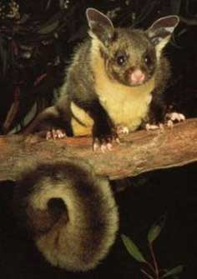
Yellow-bellied Glider

Rally Stages
Yellow-bellied Glider occurs within 5 km of Tweed stages Byrrill, Cudgera, Mooball and Urliup, and Kyogle stages Capeen, Eden, Lynches, Peacock, Toonumbar and Upper Clarence.

Status
Vulnerable (NSW)

Breeding
(Lamington_National_Park)
Young born August to September. Pouch young Yellow-bellied Gliders will be present at rally time.

Risk of adverse rally impact
No risk of adverse rally impact reported.

Description
(DEC, 2005r)
Large, active, social, vocal glider. Head and body length 30 cm, tail 45 cm. Grey to brown fur above, cream to yellow belly, dark stripe on back. Gliding membrane, wrist to ankle. Loud distinctive call, shriek to rattle (sound file included).

Distribution and habitat
Southern Queensland to Victoria, coast to western slopes of Great Dividing Range. Hollows of large trees, tall eucalypt forest, moist gullies, creek flats. Feeds on nectar, sap, honeydew, manna, pollen, insects. Large ranges 20 – 85 ha.

Threats
Habitat loss and fragmentation, loss of hollow-bearing and feed trees.

Red-tailed Black Cockatoo (Calyptorhynchus banksii)

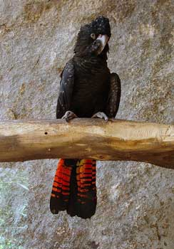
Red-tailed Black Cockatoo

Rally Stages
Red-tailed Black Cockatoo occurs within 5 km of Tweed stage Byrrill (Biolink, 2009b).

Status
Vulnerable (NSW)

Risk of adverse rally impact
Described as H/M in Tweed stage Byrrill (Biolink, 2009b)

Breeding
May to September. End of breeding season may be disrupted by rally. Nesting in vertical tree hollows of tall eucalypts (Wikipedia, 2009c).

Description
C. b. banksii is Queensland/NSW subspecies. A large cockatoo, 60 cm in length. Male all black except for two lateral bright red panels. Females slightly smaller with yellow-orange stripes in tail, yellow spots on cheeks and wings (Wikipedia, 2009c).

Distribution and habitat
Mainly drier parts of Australia. Widespread and abundant across northern half of Australia. Wide variety of habitats – eucalypt, she oak and Acacia woodlands to dense tropical rainforests..

Threats
Illegal trade in smuggled birds.

Glossy Black Cockatoo (Calyptorhynchus lathami)

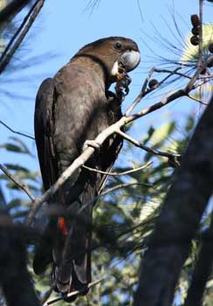
Glossy Black Cockatoo

Rally Stages
Glossy Black Cockatoo occurs within 5 km of Tweed stages Byrrill, Cudgera, Dunloe, Mooball, Cob O Corn, Lynches, Peacock (1 km), Toonumbar and Upper Clarence (1 km) (Biolink, 2009b).

Status
Vulnerable (NSW)

Risk of adverse rally impact
Described as H/M for Tweed stages Byrrill and Mooball, M/L for Cudgera and Round Mountain, and medium for Urliup (Biolink, 2009b), and H/M for Kyogle stages Peacock, Toonumbar and Upper Clarence and M/L for Capeen, Cob O Corn, Eden, Lynches, Sargents and Trenty.

These risk levels based in large part on percent presence of Allocasurina torulosa trees in field sites, even when Wildlife Atlas did not record any sightings.

Breeding
In NSW, breeding takes place from March to August (DECC, 2004).

Description
Dusky brown to black , massive bill, broad red band through tail (male). Female has pale yellow on head, neck under parts and under wing. Smaller than other black cockatoos (50 cm in length), smaller crest (Wikipedia, 2009a) (DEC, 2005f).

Distribution and habitat
Uncommon, central Queensland coast to East Gippsland, Victoria, inland NSW, Kangaroo Is. Open Coast and woodlands where she-oak species occur. Feeds almost exclusively on she-oak seeds. Nests in hollows of large eucalypt trees.

Threats
Loss of tree hollows, habitat. Illegal trade in smuggled birds. Fire.

Rose-crowned Fruit Dove (Ptilinopus regina) and Superb Fruit Dove (Ptilinopus superbus)

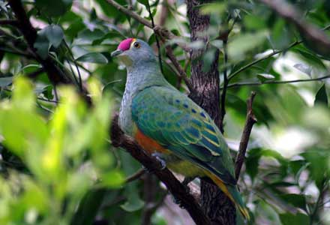
Rose-crowned Fruit Dove

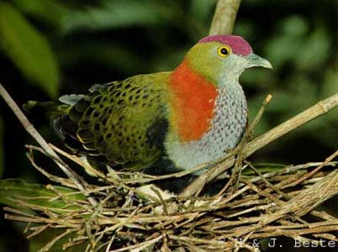
Superb Fruit Dove

Rally Stages
The Rose-crowned Fruit Dove occurs within 5 km of Tweed stage Byrrill, and Kyogle stages Capeen, Peacock and Toonumbar, and the Superb Fruit Dove within 5 km of Kyogle stages Peacock, Sargents and Upper Clarence (Biolink, 2009a, 2009b; NSWNPWS).

Status
Vulnerable in NSW

Risk of adverse rally impact
(Biolink, 2009a, 2009b) list the Rose-crowned Fruit Dove at M/L risk in Tweed stages Byrrill and Urliup, and M/L in Kyogle stages Cudgera and Round Mountain, and medium in Mooball.

(Biolink, 2009a, 2009b) list the Superb Fruit Dove as at M/L risk in Tweed stage Byrrill and in Kyogle stage Sargents.

(Biolink, 2009a, 2009b) list Fruit Doves Ptilinopus spp. at M/L risk in Tweed stage Byrrill and in Kyogle stages Capeen, Peacock and Upper Clarence, and H/M in Toonumbar.

Both species are problematic in terms of amelioration.

Breeding
Superb Fruit Dove breeds September to January (DEC, 2005m) and the Rose-crowned Fruit Dove in November and April (Australia_Zoo). Superb Fruit Doves will be breeding at rally time.

Description
Superb Fruit Dove. Small, colourful rainforest pigeon, 24 cm. Male – brightly coloured, golden-green upper, brilliant orange-vermillion neck, rich purple crown. Grey-lilac throat and breast, broad black band separates creamy-white belly. Female – light green back, purple spot on crown.

Rose-crowned Fruit Dove. Small, colourful rainforest pigeon, 24 cm. Male – rose crown edged with yellow, blue-grey white spotted head and breast, Grey-green upper, tail tip yellow and orange under. Female – mostly grey-green. Shy. Feed on vines, shrubs, trees and palms.

Distribution and habitat
Superb Fruit Dove.
Mainly northeastern Queensland to north-eastern NSW. Rainforest, eats figs and palms. Semi-nomadic.

Rose-crowned Fruit Dove. Newcastle to Cape York, eastern coast and ranges. Subtropical, dry, moist eucalypt and swamp forests, Semi-nomadic.

Threats
Clearing and degradation of habitat. Loggin, roads. Fire, weeds.

White-eared Monarch (Monarcha leucotis)
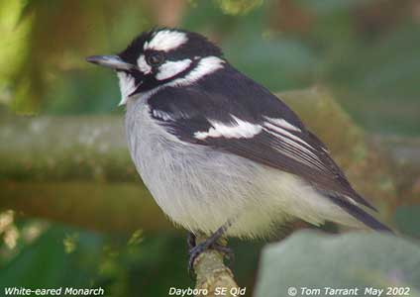
White-eared Monarch

Rally Stages
White-eared Monarch occurs within 5 km of Tweed stages Byrrill (1 km), Cudgera (1 km), Dunloe, Mooball (1 km), Round Mountain and Urliup (1 km) and Kyogle stages Capeen, Cob O Corn, Eden (1 km), Hillyards, Lynches (1 km), Sargents, Toonumbar (1 km) and Upper Clarence (Biolink, 2009a, 2009b).

Status
Vulnerable in NSW, nationally Endangered

Risk of adverse rally impact
The Biolink Ecological Assessments list the White-eared Monarch at H/M risk in Tweed stages Byrrill, Cudgera and Mooball, M/L in Round Mountain, and high in Urliup, and H/M in Kyolge stages Eden, Lynches and Toonumbar, and M/L in Capeen, Cob O Corn , Sargents and Upper Clarence.

Adverse impact on the White-eared Monarch is described as difficult to mitigate (Biolink, 2009a, 2009b).

Breeding
August to January, breeding during rally (Pizzey & Knight, 2003).

Description
Small flycatchers, black, white and grey plumage pattern. Characteristic hovering flight when foraging (DEC, 2005q).

Distribution and habitat
Eastern Queensland and NSW north coast from Cape York to mouth of Clarence River. Coastal rainforest, swamp forest and wet eucalypt forest.

Threats
Clearing and isolation of forest habitat, weed invasion.

Olive Whistler (Pachycephala olivacea)

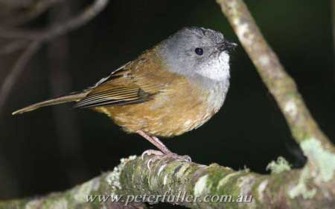
Olive Whistler

Rally Stages
The Olive Whistler occurs within 5 km of the Tweed stages Mooball and Round Mountain.

Status
Vulnerable in NSW

Risk of adverse rally impact
Biolink (2009a, 2009b) list the White-eared Monarch at M/L risk in Tweed stages Mooball and Round Mountain.

Adverse impact on the Olive Whistler is described as difficult to mitigate (Biolink, 2009a, 2009b).

Breeding
September to January (Pizzey & Knight, 2003). Beginning of breeding during rally.

Description
(DEC, 2005k)
Small stocky bird, large head, strong bill, 22 cm including 10 cm tail. Male - dark grey head, olive-brown upper, grey throat and buff-brown under. Female duller. Most rich, melodious calls of the whistlers.

Distribution and habitat
(DEC, 2005k)
Wet forests of ranges on east coast. Disjunct distribution in NSW (Barrington Tops, MacPherson Ranges, Illawarra, Snowy Mountains, Brindabella Range. Known population in Richmond – Tweed. Wet forests above 500 m. Feeds on berries and insects.

Threats
Clearing and fragmentation of habitat, fire, foxes and cats.

Brown Tree Creeper (Climacteris picumnus)

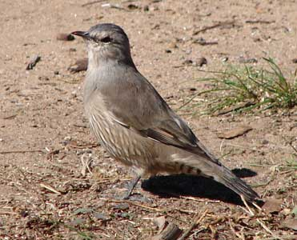
Brown Treecreeper

Rally Stages
Brown Tree Creeper occurs within 5 km of Kyogle stages Peacock and Toonumbar

Status
Vulnerable in NSW

Risk of adverse rally impact
Biolink (2009a) list the Brown Tree Creeper at M/L risk in Kyogle stages Peacock and Toonumbar.
Adverse impact on the Brown Treecreeper is described as difficult to mitigate (Biolink, 2009a).

Breeding
July to February (DEC, 2005a). Will be breeding during rally.

Description
(DEC, 2005a)
Australia’s largest treecreeper, grey-brown bird, black streaking on lower breast and belly, black bars under tail. In flight, pale buff bands on wings. Male, black and white and female, rufous and white streaking on breast

Distribution and habitat
(DEC, 2005a)
Eastern Australia, eucalypt forests and woodlands of inland plains and slopes of Divide. Eastern subspecies in eastern NSW, eucalypt woodlands and drier coastal areas. Population density of subspecies greatly reduced over much of range. Peck and probe for insects in litter, tussocks and fallen timber. Nests in tree hollows.

Threats
Fragmentation, degradation and loss of habitat, grazing, fire.

Grey-crowned Babbler (Pomatostomus temporalis)

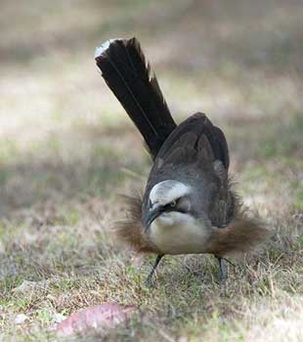
Grey-crowned Babbler

Rally Stages
Grey-crowned Babbler occurs within 5 km of Kyogle stages Peacock, Toonumbar and Upper Clarence

Status
Vulnerable in NSW

Risk of adverse rally impact
Biolink (2009a) list the Grey-crowned Babbler at M/l risk in Kyogle stages Peacock, Toonumbar and Upper Clarence.

Adverse impact on Grey-crowned Babbler is described as difficult to mitigate (Biolink, 2009a, 2009b).

Breeding
June to October (Pizzey & Knight, 2003). Will be breeding during rally; juvenile birds present.

Description
(DEC, 2005g)
Largest Australian babbler, 30 cm, bill shaped like a downwards curving sword, broad white eyebrow, grey crown stripe. Dark band from bill through eye, dark grayish-brown upper, paler brown under. In flight, white wing tips, orange-buff wing patches. Broad round wings make flight laborious. Forage for invertebrates on trees, branches, ground.

Distribution and habitat
(DEC, 2005g)
Throughout northern and southeastern Australia. Eastern sub-species in NSW on western slopes of Divide. Box-gum woodlands on slopes, box-cypress pine and box woodlands.

Threats
Clearing of woodland remnants, grazing, nest predation.

EPBC Nationally threatened fauna within 5 km not described as at risk from rally

Brush-tailed Rock Wallaby (Petrogale penicillata)

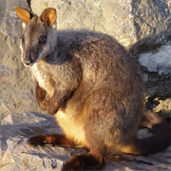
Brush-tailed Rock Wallaby

Rally Stages
Brush-tailed Rock Wallaby occurs within 5 km of Tweed stage Byrrill and Kyogle stages Lynches, Peacock, Sargents, Toonumbar and Upper Clarence (NSWNPWS).

Status
Endangered (NSW), Vulnerable (Qld and nationally), Critically endangered (Victoria), Extinct (ACT) (National_Parks_Journal, 2006)

Breeding
Breeding is continuous. Immature Brush-tailed Wallabies likely present at rally time.

Description
(National_Parks_Journal, 2006)
Long, bushy, dark rufous-brown tail; long, thick, brown body fur rufous on rump and grey on shoulders, pale on chest and belly; white cheek stripe, black head stripe; fast and agile; 8 kg (m), 6 kg (f).

Distribution and habitat
Great Dividing Range, south-east Queensland to western Victoria, fragmented. Rocky escarpments, outcrops, cliffs. Browse on grasses, forbs, foliage and fruits of shrubs and trees.

Threats
Habitat degradation, foxes and dogs, competition with feral goats, fire.

NSW threatened fauna within 5 km not described as at risk from rally

Squirrel Glider (Petaurus norfolcensis )

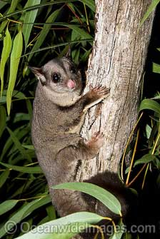
Squirrel Glider
http://www.oceanwideimages.com/categories.asp?cID=454

Rally Stages
Squirrel Glider occurs within 5 km of Tweed stages Byrrill, Cudgera, Dunloe, Mooball, Round Mountain and Urliup, and Kyogle stages Cob o Corn, Eden, Lynches, Peacock and Toonumbar

Status
Vulnerable (NSW)

Breeding
Breed in second half of year (Marsupial_Society_of_Australia, 2006). Squirrel Gliders will be breeding at rally time.

Description
Head and body length 20 cm. Blue-grey to brown-grey fur above, white belly, end third of tail black, dark stripe from between eyes to mid-back, tail soft and bushy, 27 cm (DEC, 2005o).

Distribution and habitat
Sparsely distributed from northern Queensland to western Victoria. Nest in bowl-shaped tree hollows. Box, Ironbark, River Red gum. Feeds on Acacia gum, eucalypt sap, nectar, honeydew, manna, invertebrates, pollen.

Threats
Habitat loss and fragmentation, loss of hollow-bearing trees, flowering understory. Can be caught in barbed wire.

Brush-tailed Phascogale (Phascogale tapoatafa)

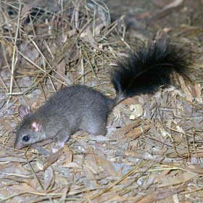
Brush-tailed Phascogale

Rally Stages
Brush-tailed Phascogale occurs within 5 km of Tweed stage Byrrill and Kyogle stages Capeen, Cob O Corn, Eden, Lynches, Toonumbar, Upper Clarence (NSWNPWS).

Status
Vulnerable (NSW)

Breeding
Mating May through July. Immature Brush-tailed Phascogales may be present at rally time.

Description
(DEC, 2005b)
Tree-dwelling marsupial carnivore, black bushy “bottlebrush” tail, fur grey above, pale cream below, conspicuous black eyes, large naked ears, head and body 20 cm, tail 20 cm.

Distribution and habitat
Patchy distribution around coast of Australia. NSW: In forest, NE and SE Great Dividing Range.

Threats
Threats: foxes, cats, destruction and fragmentation of habitat, competition for nesting hollows with introduced honey bee.

Additional NSW threatened fauna within 5 km of rally stages
Green-thighed Frog
Large-eared Pied Bat
Double-eyed Fig Parrot
Pouched Frog
Loveridges Frog
Square-tailed Kite
Black Bittern
Rufous Scrub-bird
Barred Cuckoo-shrike
Wompoo Fruit Dove
Comb-crested Jacanda
Powerful Owl
Masked Owl
Sooty Owl
Coastal Planigale
Yellow-bellied Sheathtail Bat
Eastern Free-tail Bat
Eastern Tube-nosed Bat
Eastern Blossom-bat
Hoary Wattled Bat
Little Bent-wing Bat
Eastern Bent-wing Bat
Hoary Wattled Bat
Golden-tipped Bat
Little Bent-wing Bat
Eastern Bent-wing Bat
Large-footed Myotis
Eastern Long-eared Bat
Stephen’s Banded Snake
Black-necked Stork
Marbled Frogmouth
Common Blossum-bat
Masked Owl
Sooty Owl
Little Tern
Mangrove Honeyeater
Parma Wallaby
Rufous Bettong
Long-nosed Potoroo
White-crowned Snake
Pale-headed Snake
Magpie Goose
Red-backed Button Quail
Black-striped Wallaby
Barred Cuckoo-shrike
Hoary Wattled Bat
Barking Owl
Eastern False Pipistrelle
Greater Broad-nosed Bat
Richmond Birdwing Butterfly

Discussion

There are substantial potential risks to national and NSW threatened fauna species that occur within 5 km of the Repco Rally Australia stages, and these risks are still medium to high for many species after their diurnal/nocturnal cycles are taken into consideration (Biolink, 2009a, 2009b). A number of amelioration measures are proposed in the Biolink reports such as erecting fences, using bird-scaring sirens and having volunteers act as koala guardians, but there is no documentary evidence as to their likely effectiveness in preventing deaths of threatened Australian species during the rally (Ambrose, 2009). In addition some of these measures may only increase stress levels in animals living close to the rally stages, and in some cases disrupt the breeding cycle. Marsupials may abandon their young, and birds their eggs if stress levels are high (Ambrose, 2009; Graham, 2009). It is therefore possible that many species in addition to those discussed in the Biolink reports may be adversely impacted by the rally. If a single individual of the endangered Spotted-tailed Quoll is killed, the area of occupancy of the species can be reduced (Biolink, 2009b). A decrease in area of occupancy is likely for the three nationally threatened frogs. Any of these factors, or several taken together could conceivably lead to a decrease in the population size of threatened species over the long term if the rally is allowed to continue over the intended ten-year period. Potentially significant impacts on nationally threatened species, which comprise matters of national environmental significance under the EPBC Act, have been identified in Ambrose (2009), Graham (2009) and briefly in Biolink (2009b), requiring a referral of the rally proposal to the Commonwealth Minister for the Environment. Nevertheless, to the author’s knowledge this has not yet happened at the date of writing (17 August 2009), little more than 2 weeks before the scheduled start of the rally.

Conclusion
These considerations lead to the conclusion that the Repco Rally Australia should not be held in these areas of northeastern NSW that host relatively undisturbed ecosystems and such large numbers of national and NSW threatened fauna species.

Photo credits
Koala and baby, http://blog.lib.umn.edu/csomweb/pbanwart/2009/05/koala_bears_1.html
Spotted-tailed Quoll, http://michaelsnedic.com/galleries/australian-mammals-gallery/
Fleay’s Frog, http://www.savethefrogs.com/gallery/d/324-9/Mixophyes_fleayi_Fleays_Barred_Frog
Giant Barred Frog, http://www.savethefrogs.com/gallery/d/774-3/Mixophyes-iteratus-Giant-Barred-Frog
Eatern bristlebird, http://www.fnpw.org.au/Images/Projects/PlantsandWildlife/easternBristlebird.jpg
Three-toed Snake-toothed Skink, http://www.geckosunlimited.com/community/aussie-geckos-others-diplodactylus-strophurus-saltuaris-phyllurus-oedura-etc/40119-photo-guide-australian-lizards-pt2.html
Black-breasted Button Quail, http://www.graemechapman.com.au/cgi-bin/viewphotos.php?c=628
Red Goshawk, http://www.landmanager.org.au/images/Erythrotriorchis%20radiatus%20Ian%20Morris.jpg
Albert;s Lyrebird, http://www.arkive.org/alberts-lyrebird/menura-alberti/image-G7678.html
Grey-headed Flying Fox, http://www.environment.gov.au/biodiversity/science/abbbs/images/grey-headed-flying-fox.jpg
Large-eared Pied Bat, http://www.threatenedspecies.environment.nsw.gov.au/tsprofile/popupImage.aspx?id=24634
Brush-tailed Phascogale Photo Ken Stepnell DEC (http://fnpw.org.au/ForSupporters/PAWS/enews062/Brush-tailedPhascogale.htm)
Brush-tailed Phascogale
(http://www.chilternvic.com/visitor_activities/activities_mt-pilot-national-park.html
Brush-tailed Rock Wallaby
(http://www.conservationvolunteers.com.au/wildfutures/rock-wallaby.html)
Red-legged Pademelon (http://www.anhs.com.au/pademelon_3.htm)
Yellow-bellied Glider http://www.nvca.green.net.au/ybglider.jpg
Red-tailed Black Cockatoo http://www.treknature.com/gallery/Europe/Germany/photo128463.htm
Glossy Black Cockatoo http://www.ozanimals.com/image/albums/australia/Bird/normal_Glossy-black-cockatoo-m.jpg
Rose-crowned Fruit Dove http://photogallery.canberrabirds.org.au/images/Fruit-Dove_Rose-crowned_Luff.jpg
Superb Fruit Dove http://www.wettropics.gov.au/st/rainforest_explorer/Resources/Images/animals/birds/superbDove.jpg
White-eared Monarch, Australian Bird Image Database
http://www.aviceda.org/abid/birdimages.php?action=birdimage&bid=1296&fid=69&p=1&pagesize=1
Olive Whistler http://www.aviceda.org/abid/search.php?action=searchresult&p=4&keyword=olive+whistler
Grey-crowned Babbler http://www.aviceda.org/abid/search.php?p=15&action=searchresult&keyword=Grey-crowned+babbler&pagesize=1
Brown Treecreeper http://www.mdahlem.net/img/ozbirds/brtrcrp_6853_big.jpg
Brown Treecreeper http://www.mdahlem.net/birds/15/brtreecr.php
Squirrel Glider http://www.oceanwideimages.com/categories.asp?cID=454
Green-thighed Frog http://www.geocities.com/gem3007/litbrevi.gif

References

Relevant site
Threatened Species of the Northern Rivers http://www.wiresnr.org/threathenedfauna.html

