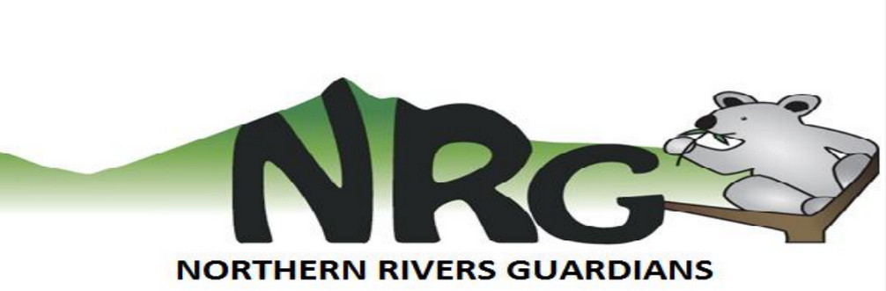
application for membership in the northern rivers guardians, inc.
(incorporated under the Associations Incorporation Act 1984)

Please tick one: New Member Renewal

applicant:

I, _______________________________________________________________________,
(full name)

of _______________________________________________________________________
(address)

__________________________________________ _______________________________ (occupation) (phone)

_______________________________________________________________________
(email address)

hereby apply to become a member of Northern Rivers Guardians, Inc.

In the event of my admission as a member, I agree to be bound by the rules of the association for the time they are in force.

____________________________________ __________________________
(signature of applicant) (date)

How would you like to contribute to the group? Please tick all that apply.
 | emailing/letter writing |  | public speaking (community groups, meetings)
 | web or graphic design |  | information stalls (markets, footpath, etc.)
 | research |  | attend rallies and protests
 | fundraising (raffle tickets, cooking, etc.) |  | media releases and media speaking
 | helping to organise events/activities |  | developing campaign resources

Other _____________________________________________________________________________

Please return completed form to the NRG Secretary: secretary@northernriversguardians.org
Dues are payable by direct deposit: Summerland Credit Union BSB 728 728, Acct 22300597

official use only

accepted: yes / no date: _________________

